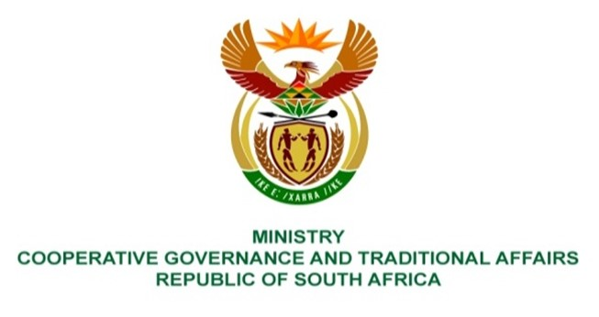

NATIONAL ASSEMBLY
QUESTIONS FOR WRITTEN REPLY

QUESTION NUMBER 2279
DATE OF PUBLICATION: 05 November 2021

Mr K Ceza (EFF) to ask the Minister of Cooperative Governance and Traditional Affairs:
(a) What interventions has she put in place to salvage the 10 bankrupt municipalities in the Eastern Cape, which are at the brink of collapsing and told the Auditor-General they cannot carry on and (b) who will be held liable for the collapse of the specified municipalities? NW2562E

REPLY:

- The Auditor-General Report for 2019/20 identified the following ten (10) municipalities in the Eastern Cape Province as they indicated in their Annual Financial Statements that they are a going concern uncertainty, and their total current liabilities exceeded the total current assets.

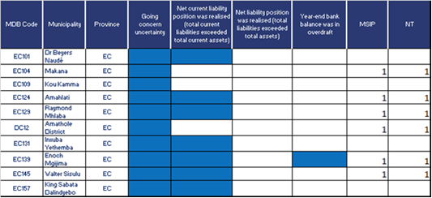

Out of the ten (10) municipalities, the following six (6) municipalities (Makana, Amahlathi, Raymond Mhlaba, Amathole, Enoch Mgijima and Walter Sisulu) were included by the Minister of Cooperative Governance and Traditional Affairs (CoGTA) in the list of dysfunctional municipalities in the Eastern Cape and draft Municipal Support and Interventions Plans have been developed for these municipalities taking into consideration an analysis conducted by National Treasury.

Three (3) out of the ten (10) the municipalities identified in the Auditor-General report have been placed under Section 139 intervention and they are Makana and Enoch Mgijima and have FRPs in place and they are jointly monitored on a monthly basis whilst the Amathole FRP has just been approved and will be implemented and monitored.

Dr Beyers Naudé, Koukamma and Inxuba Yethemba local municipalities, have been engaged by the province to participate in a financial management support programme in partnership with the National Business Initiative to address their financial challenges, part of the initiatives in the NBI include:
- Group coaching of financial management personnel within municipalities.
- Deployment of support staff from the pool of consultants from NBI
- Training of municipal officials on financial reporting.

Dr Beyers Naudé, Koukamma and Inxuba Yethemba local municipalities also are set to benefit from the partnership with the Development Bank of South Africa (DBSA) and the projects include development of revenue enhancement strategies for municipalities and assisting them with the embedded energy generation to overcome the high cost of electricity.

King Sabata Dalindyebo, Walter Sisulu and Amahlathi have also been approved by DBSA for funding on embedded energy generation and for the development of revenue enhancement strategies.

- Out of the ten (10) municipalities, the provincial department instituted investigations in line with Section 106 of the Local Government Municipal Systems Act in seven (7) of the municipalities (Makana, Amahlathi, Raymond Mhlaba, Amathole, King Sabata Dalindyebo, Emoch Mgijima and Inxuba Yethemba). Investigations are at various stages. Further, the Directorate for Priority Crime Investigation (Hawks) is conducting investigations in two (2) of the municipalities (King Sabata Dalindyebo and Makana).

