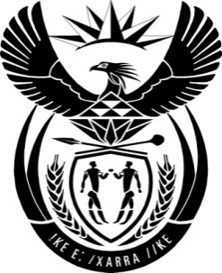

THE PRESIDENCY: REPUBLIC OF SOUTH AFRICA
Private Bag X1000, Pretoria, 0001
NATIONAL ASSEMBLY
QUESTIONS FOR WRITTEN REPLY

QUESTION NO: 2268

Date Published: October 2016

The Leader of the Opposition (DA) to ask the President of the Republic:
(1) With reference to his reply to oral question 9 on 19 June 2013, what are the details of the nature of his relationship with a certain family (name furnished);
(2) (a)(i) in which capacity and (ii) on what dates in 2015 did he visit the specified family at their residence and (b) what was the reason for each visit;
(3) has any member of the family ever given (a) him and/or (b) any member of his family a gift, no matter how trivial; if so, in each case, what are the details of the gift? NW2600E
Reply:
The questions asked form part of the subject matter of the Report into Allegations of improper and unethical conduct by the President and other state functionaries on matters relating to the removal and appointment of Ministers and Executives of State Owned Enterprises. It is clear from the remedial action to be taken that the Report is inconclusive. After the report was released, I have since indicated that I am giving consideration to the contents of the report in order to ascertain whether it should be a subject of a court challenge. I therefore cannot answer these questions as they form part of the said report.

