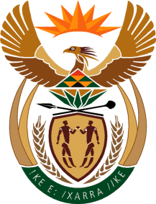

MINISTRY OF TOURISM

REPUBLIC OF SOUTH AFRICA

Private Bag X424, Pretoria, 0001, South Africa. Tel. (+27 12) 444 6780, Fax (+27 12) 444 7027

Private Bag X9154, Cape Town, 8000, South Africa. Tel. (+27 21) 469 5800, Fax: (+27 21) 465 3216

Ref: TM 2/1/1/10

NATIONAL ASSEMBLY:

QUESTION FOR WRITTEN REPLY:
Question Number: 2265
Date of Publication: 12 June 2015
NA IQP Number: 21
Date of Reply: 17 July 2015

Ms P T van Damme (DA) to ask the Minister of Tourism:
Whether (a) his department and (b) any entities reporting to him has paid out the remainder of any employee's contract before the contractually stipulated date of termination of their contracts since the 2008-09 financial year up to the latest specified date for which information is available; if so, (i) how much has (aa) his department and (bb) entities reporting to him spent on each such payout, (ii) to whom were these payouts made and (iii) what were the reasons for the early termination of the contracts in each specified case? NW2624E

REPLY:

(a) The department did not exist in the financial years of 2008/09 - 2009/10.
The department has not paid out the remainder of any employee’s contract since the 2010/11 financial year until date.
(aa) (i) – (iii) Not applicable

(b) SA Tourism has paid out the remainder of a contract.
(bb)
- R1 512 781.90 (R1,080 022.90 was paid out 2011/12 and R437 759 was paid out 2012/2013)
- Previous CEO, Ms T January-McLean 2011/12- 2012/13
- Separation by mutual agreement with the SAT Board

