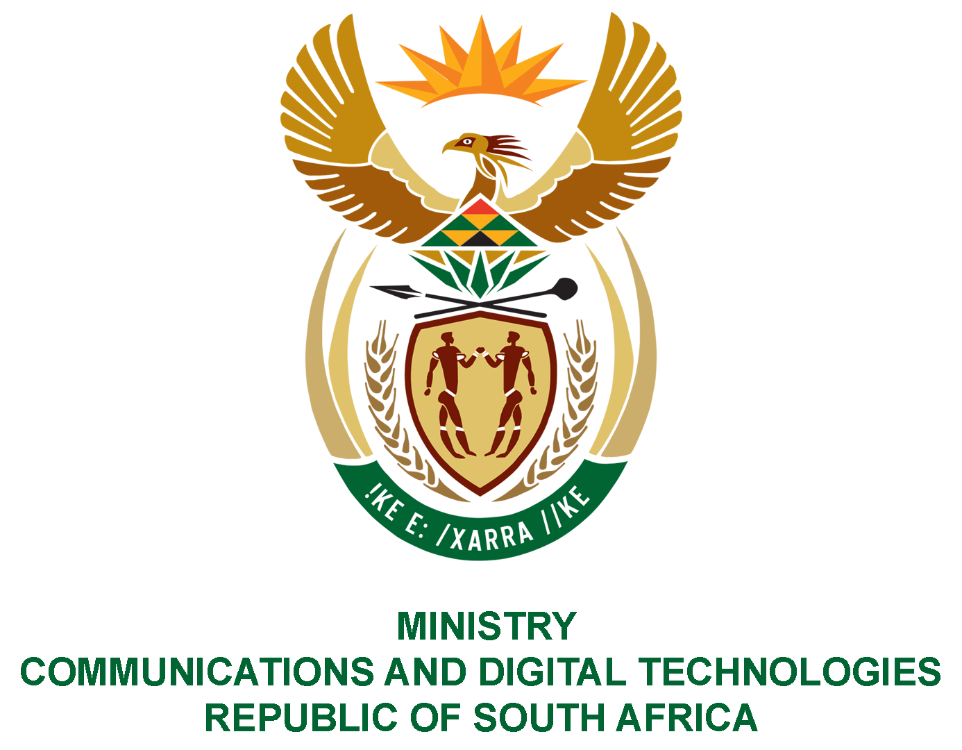

PARLIAMENT OF THE REPUBLIC OF SOUTH AFRICA

NATIONAL ASSEMBLY

WRITTEN REPLY

QUESTION: 2263

DATE OF PUBLICATION: 10 SEPTEMBER 2021
QUESTION PAPER NO: 22

Ms Z Majozi (IFP) to ask the Minister of Communications and Digital Technologies:

(1) In light of the fact that the dispute between mobile network operators and the Independent Communications Authority of South Africa is set to remain unresolved after the 30 November 2021 extended deadline on temporary spectrum, as gazetted, what steps will the Government take to ensure smooth availability of internet to facilitate working-from-home;

(2) whether the Government intends to find a permanent solution of making the spectrum available; if not, what is the position in this regard; if so, what steps are being taken to bring all parties to a consensus?

NW2571E
REPLY:
- The dispute between mobile network operators and the Independent Communications Authority of South Africa (ICASA) was finally resolved on the 15th September 2021 with the granting of a court order, in terms of which the decisions taken by the Authority to publish the Invitations-to-Apply (ITAs) for the release of high demand spectrum and licensing of the Wireless Open Access Network (WOAN) was set aside and the matter was referred back to the Authority for reconsideration.

In light of the above, the Authority will, during the course of Quarter 3, make an announcement on the reconsideration of the matter as directed by the court.

(2) The Department – as the policy maker – will work with ICASA and all stakeholders to ensure that ICASA’s initiation of the process of licensing of spectrum.

