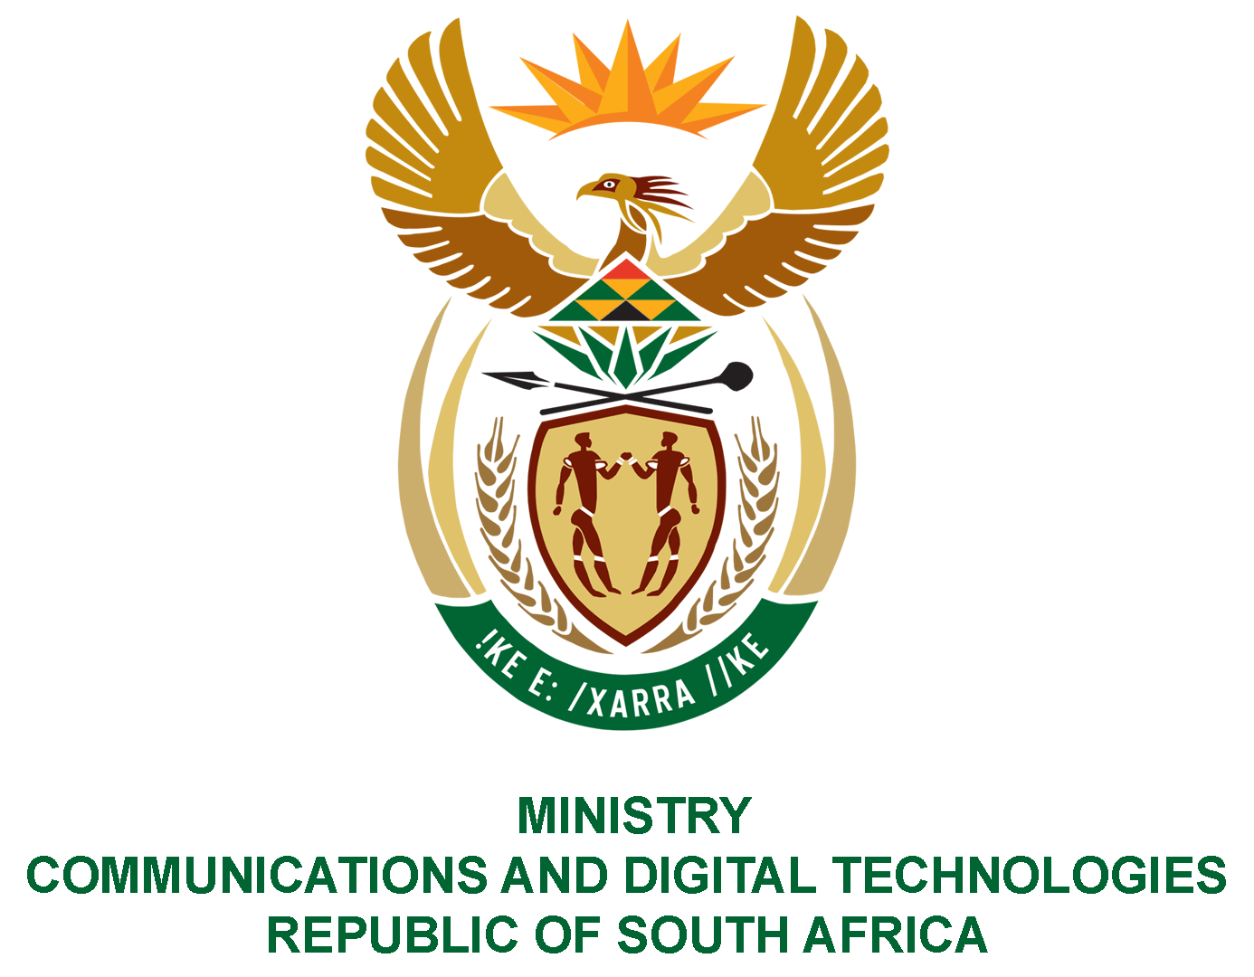

PARLIAMENT OF THE REPUBLIC OF SOUTH AFRICA

NATIONAL ASSEMBLY

WRITTEN REPLY

QUESTION: 2262

DATE OF PUBLICATION: 10 SEPTEMBER 2021
QUESTION PAPER NO: 22

Ms Z Majozi (IFP) to ask the Minister of Communications and Digital Technologies:

Whether, in light of the fact that the dispute between the Independent Communications Authority of South Africa and mobile network operators has dragged on for some time in the courts, preventing the auctioning of much-needed spectrum, the Government has any immediate plans to release spectrum that is held and used by broadcasters which is required for 5G bidding; if not, why not; if so, what are the (a) plans, (b) dates and (c) other time frames for the release of the spectrum?

NW2570E
REPLY:
The dispute between mobile network operators and the Independent Communications Authority of South Africa (ICASA) was finally resolved on 15 September 2021 with the granting of a court order, in terms of which the decision taken by the Authority to publish the Invitations-to-Apply for the release of high demand spectrum and the licensing of the Wireless Open-Access Network (WOAN), was set aside and the matter was referred back to the Authority for reconsideration. Therefore, the Authority will, during the course of Quarter 3, make an announcement on the reconsideration of the matter as directed by the court.
In light of the above, the Department of Communications and Digital Technologies intends to conclude the digital migration process by the end of the 2021-2022 Financial Year. The Minister of Communications and Digital Technologies will outline key milestones before end of October 2021.
This will place ICASA in a position to licence the digital dividend currently occupied by broadcasting service licensees, and which was the subject of the litigation, without any contention. The Department is committed to providing support to ICASA to ensure that it delivers on its legislated mandate and strategic objectives.

