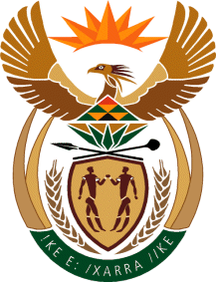

MINISTRY: COMMUNICATIONS
REPUBLIC OF SOUTH AFRICA
Private Bag X 745, Pretoria, 0001, Tel: +27 12 473 0164 Fax: +27 12 473 0585
Tshedimosetso House,1035 Francis Baard Street, Tshedimosetso House, Pretoria, 1000

NATIONAL ASSEMBLY
QUESTION FOR WRITTEN REPLY
QUESTION NUMBER: 2262
DATE OF PUBLICATION: 21 OCTOBER 2016

Mr M W Rabotapi (DA) to ask the Minister of Communications:
With reference to her reply to question 2002 on 6 October 2016, did her department pledge an amount of R3 million to support the Thank You SABC music concert held at the Orlando Stadium on 10 September 2016; if not, what is the position in this regard; if so, what are the relevant details? NW2594E

REPLY: MINISTER OF COMMUNICATIONS

The Department of Communications did not pledge any amount to support the Thank You SABC music concert held at the Orlando Stadium on 10 September 2016.

MR NN MUNZHELELE
DIRECTOR GENERAL [ACTING]
DEPARTMENT OF COMMUNICATIONS
DATE:

MS AF MUTHAMBI (MP)
MINISTER OF COMMUNICATIONS
DATE

