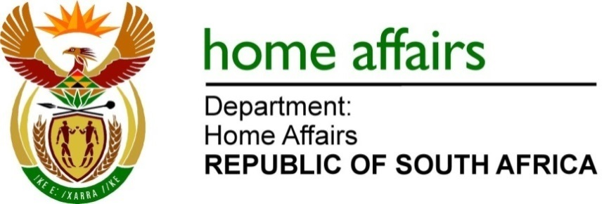
NATIONAL ASSEMBLY

QUESTION FOR WRITTEN REPLY

QUESTION NO. 2260

DATE OF PUBLICATION: FRIDAY, 9 OCTOBER 2020

INTERNAL QUESTION PAPER 36 – 2020

2260. Ms L L van der Merwe (IFP) to ask the Minister of Home Affairs:

- What total amount has his department spent on advertising in media such as (a) radio, (b) television, (c) newspapers and (d) social media;
- whether he will provide Ms L L van der Merwe with a list of media institutions that benefited from the advertising in the past 12 months; if not, why not; if so, what are the relevant details? NW2832E

REPLY

- (a) Radio - R 10,596,343.00
- (b) Television - R 2,558,411.13
- (c) Newspapers - R 3,477,185.20
- (d) Social Media - R 636,500.00

- List of Media Institutions:
(a) Radio
- Mediamark
- Msg Afrika Technologies
- Primedia Broadcasting
- Sabc
- United Stations
- Community Radio
- Alex Fm

- Television
- E SAT TV
- Dstv Media Sales
- Mediamark
- Sabc
- Media Mansion
- Mediamark
- MVM Multimedia
- Zallywood Ltd

- Newspapers
- Arena Holdings
- Independent Newpapers
- Media 24
- Vuk’uzenzele
- Ads 24
- Onshelf Trading Forty Four
- The Citizen
- Tiso Blackstar Group

- Social media
- Arena Holdings
- Independent Newspapers
- Media24

Remarks: Reply: Approved / Not Approved

Mr J W McKay Dr PA Motsoaledi, MP
A/Director-General Minister of Home Affairs
Date: Date:

