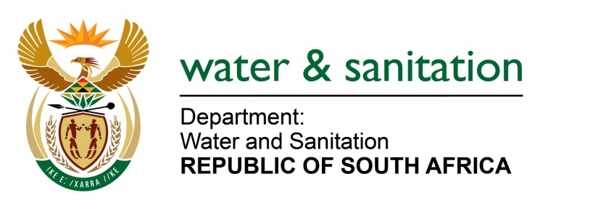

NATIONAL ASSEMBLY

FOR WRITTEN REPLY

QUESTION NO 2260

DATE OF PUBLICATION IN INTERNAL QUESTION PAPER: 21 OCTOBER 2016
(INTERNAL QUESTION PAPER NO. 31)

2260. Ms T E Baker (DA) to ask the Minister of Water and Sanitation:
(1) By what date will she give notice in the Government Gazette of the establishment of the newly amalgamated Mhlathuze and Umgeni Water Board, in terms of section 28(1) of the Water Services Act, Act 108 of 1997, as amended;
(2) whether she will require that a selection panel be formed in terms of section 3(1) of schedule 1 of the specified Act; if not, why not; if so, by what date will the specified panel be established;
(3) by what date will (a) the specified water board be fully operational and (b) a permanent (i) board and (ii) chairperson be appointed? NW2591E
---00O00---

REPLY:
(1) It is anticipated that the establishment of the single KwaZulu-Natal Water Board will be gazetted during the 2017/18 financial year. The establishment will be dependent on the outcome of the due diligence exercise.
(2) Yes, a selection panel will be constituted to recommend the appointment of Board Members for the single KwaZulu-Natal Water Board. The selection panel will be appointed during the 2017/18 financial year.
(3)(a) During the course of the 2017/18 financial year.
(3)(b)(i)During the course of the 2017/18 financial year.
(3)(b)(ii)During the course of the 2017/18 financial year.
---00O00---

