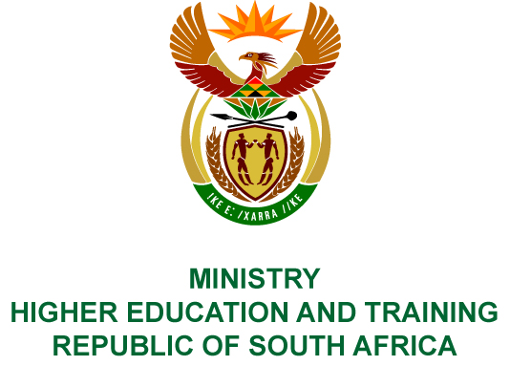
Private Bag X893, Pretoria, 0001, Tel (012) 312 5555, Fax (012) 323 5618
Private Bag X9192, Cape Town, 8000, Tel (021) 469 5150, Fax: (021) 465 7956
Memorandum from the Parliamentary Office
NATIONAL ASSEMBLY
FOR WRITTEN REPLY
QUESTION 226
DATE OF PUBLICATION OF INTERNAL QUESTION PAPER: 16/02/2018

(INTERNAL QUESTION PAPER NO 2 OF 2018)
Ms N Nolutshungu (EFF) to ask the Minister of Higher Education and Training:
Whether any of the board members of the National Institute for Humanities and Social Sciences were recipients of any grant awarded by the Catalytic Research Projects of the specified institute in the (a) 2014-15, (b) 2015-16 and (c) 2016-17 financial years; if so, (i) what is the name of each recipient, (ii) what amount has each recipient been awarded in grant funding as at 13 November 2017, (iii) what amount is each recipient still to be awarded, (iv) what was each grant awarded for and (v) did each grant comply with the cost cutting measures and regulations of (aa) the National Treasury, (bb) her department and (cc) the Auditor-General of South Africa?
NW247E
REPLY:
The National Institute for Humanities and Social Sciences (NIHSS) has provided the following responses to the questions posed.
Financial years | - Name of each recipient | - Amount awarded | - Still to be awarded | - Reasons for awarding grant
- 2014/15 | Prof Pamela Maseko (Co-project leader) | R850 000 | N/A as Prof Maseko no longer serves on the Board | Catalytic project funding - Set up the National Institute for Humanities and Social Sciences
- 2015/16 | Prof Pamela Maseko | R1 547 000 | N/A as Prof Maseko no longer serves on the Board | Catalytic project funding
- 2016/17 | None | None | None | None
- (aa) The expenditure complied with the NIHSS’s policies. The NIHSS is neither a Department, nor a constitutional institution, nor a public entity listed in Schedule 2 or 3, and therefore the Public Finance Management Act is not applicable to the NIHSS.
(bb) Spending is managed by the NIHSS in terms of its policies.
(cc) The Auditor-General of South Africa audits the NIHSS in terms of Section 38 of the Higher Education Act and since its inception has received unqualified audit opinions.

