MINISTRY: PUBLIC SERVICE AND ADMINISTRATION

REPUBLIC OF SOUTH AFRICA

NATIONAL ASSEMBLY

QUESTION FOR WRITTEN REPLY

DATE: 10 JUNE 2022

QUESTION NO.: 2257.

Dr M M Gondwe (DA) to ask the Minister of Public Service and Administration:
(1) With reference to the reply to question 1102 on 17 May 2022, on what dates were each of the Chief Directors, currently earning a salary at level 15, appointed at the specified salary level at the (a) national and (b) provincial level;
(2) what are the reasons that the Chief Directors in the (a) Kwa-Zulu Natal Department of Health and (b) Gauteng Department of Sport, Arts, Culture and Recreation are earning a salary at level 16;
(3) what are the reasons that heads of department in some provincial departments are earning a salary at level 15 and in other provinces they are earning a salary at level 16;
(4) what are the reasons that the (a) Chief Executive Officer and (b) Chief Technology Officer in the National Department of Co-operative Governance are earning a salary at the same salary level as the (c) Director-General for Co-operative Governance? NW2672E

REPLY:

- The dates on which each of the Chief Directors, currently earning a salary at salary level 15, were appointed on this salary level at the (a) national and (b) provincial level are indicated in the table below:

Dates on which each of the Chief Directors earning a salary at salary level 15 were appointed on that level
as on 28 February 2022
Province | Department | Component | Job title | Event date
Eastern Cape | Education |  | Chief Director: Financial Management Services | 2021-10-01
Free State | Office of the Premier |  | Chief Director | 2006-01-01
Gauteng | Human Settlements |  | Chief Director | 2013-12-01
 | Office of the Premier |  | Chief Director | 2010-08-01
 |  |  |  | 2014-04-01
 | Provincial Treasury | Infrastructure Financing Agency | Chief Director | 2013-09-01
 |  |  | Chief Director: Project Finance | 2016-11-01
 |  | Provincial Treasury | Chief Director | 2000-11-01
KwaZulu-Natal | Finance |  | Chief Director: Municipal Finance | 2010-12-01
 | Public Works |  | Chief Director: Corporate Services | 2003-05-01
Limpopo | Economic Development, Environment and Tourism |  | Chief Director: Commercial Operation | 2017-06-01
National | Agriculture, Land Reform and Rural Development |  | Chief Director: Monitoring & Evaluation | 2009-12-01
 |  |  | Chief Director: National Rural Youth Service Corps | 2010-12-01
 |  |  | Chief Director: Policy Research | 2012-04-01
 | Basic Education |  | CD: Strategic Planning Research & Co-Ordination | 2011-10-01
 | Environment, Forestry and Fisheries |  | Chief Director L14 | 2008-04-01
 |  |  |  | 2012-01-01
 |  |  |  | 2012-04-01
 | Government Communication and Information System |  | Chief Director: Content And Writing | 2009-04-01
 |  |  | Chief Director: Entity Oversight | 2015-07-01
 |  |  | Chief Director: Provincial And Local Liaison | 2013-03-01
 | Health |  | CD: CCOD & Occupational Health | 2014-12-19
 |  |  | Chief Director | 2010-04-01
 | Mineral Resources and Energy |  | Chief Director: Economic Growth & Global Relations | 2014-06-11
 | National Treasury | Government Technical Advisory Centre | Chief Director: Financial Management | 2008-12-01
 |  |  | Chief Director: Transaction Advisory Services | 2007-09-01
 |  | National Treasury | Chief Director: Legal Tax Design | 2014-05-01
 |  |  | Chief Director: Legislation | 2008-07-01
 |  |  | Chief Director: Regulatory Impact Assessment | 2005-11-01
 |  |  | Chief Director: Tax Specialist | 2009-01-26
 |  |  | Chief Director: Technical Support Services | 2013-09-01
 |  |  | Chief Director: Information Technology | 2012-02-01
 |  |  | Chief Director: Legal Services | 2012-04-01
 | Planning, Monitoring and Evaluation |  | Chief Director: Education & Skills | 2010-08-01
 |  |  | Chief Director: Frontline Monitoring & Support | 2016-12-01
 |  |  | Chief Director: Health | 2013-04-01
 |  |  | Chief Director: Social Cohesion Protection & Gender | 2011-04-01
 | Public Service and Administration |  | Chief Director: Human Resource Development. | 2012-12-01
 | Statistics South Africa |  | Chief Director: Price Statistics | 2012-05-01
 |  |  | Chief Director: Programme Office | 2002-05-01
 | Trade, Industry and Competition |  | Cd: Investment Promotion & Facilitation | 2015-04-01
 |  |  | Chief Director: Consumer And Corporate Regulation | 2014-05-01
Western Cape | Transport and Public Works |  | Chief Director | 2001-02-01
Data source: PERSAL

- The reason why the KwaZulu Natal Department of Health is paying the Chief Director: IDMTS on salary level 16 is because an offer of employment was made to him, by the Development Bank of South Africa, on a salary package which fell within salary level 16 in the Public Service. In order to retain his services, a counter-offer was made by the department on the nearest higher salary package compared to the offer received.

The Chief Director in the Gauteng Department of Economic Development, paid on salary level 16, was appointed as the Chief Executive Officer (CEO) of the Cradle of Humankind World Heritage Site and Dinokeng Projects on 1 January 2022. This was done in accordance with the approved organisational and salary structure below:

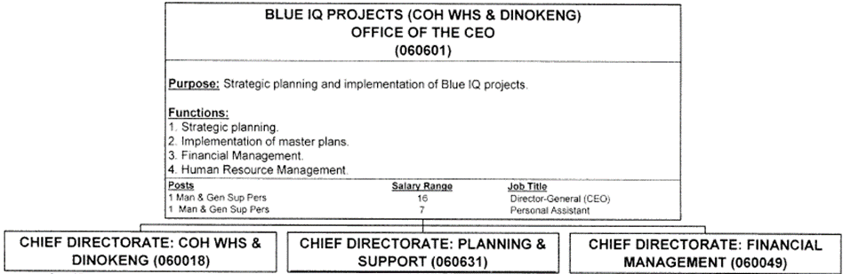

- The appointments of heads of departments on salary level 15 and others on salary level 16 is based on the service delivery model of the departments. Furthermore, the size of the departments is also taken into consideration, including client group, geographical distribution and the availability of funds within the Department. As a result, the upgrading of the Head of the Department leads to the upgrading of the lower level posts including the performer level and such leads to an increase in the compensation of employees (CoE), hence the differences of salary levels.

- According to the information submitted by the Department of Cooperative Governance:

4.1 The Chief Executive Officer in the National Department of Cooperative Governance is the Head of the Municipal Infrastructure Support Agency (MISA), which is a government component of the department established in terms of section 7A of the Public Service Act, 1994. The CEO is the accounting officer of the component as contemplated in section 36 of the Public Finance Management Act, 1999 (PFMA) and thus has all the responsibilities that accounting officers of departments have in accordance with the PFMA. The job of the Head/CEO of MISA was graded by the DPSA at salary level 16, which is comparative to that of a Director-General and it was concurred by the MPSA on 28 March 2012.

4.2 The Chief Technology Officer was appointed on a one-year contract additional to the establishment to develop and lead the implementation of the Departmental Corporate Governance of ICT Strategy and to transfer the necessary skills to the Department. Although the incumbent’s income in the private sector was significantly higher than what is available in the public sector, he agreed to the maximum notch of salary level 16 for the duration of the one-year contract. He will return to the private sector at the conclusion of the contract.
End

