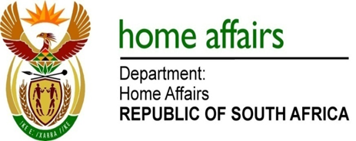

NATIONAL ASSEMBLY

QUESTION FOR WRITTEN REPLY

QUESTION NO. 2256

DATE OF PUBLICATION: Friday, 21 October 2016

INTERNAL QUESTION PAPER 31 OF 2016

2256. Mr M Waters (DA) to ask the Minister of Home Affairs:

- (a) Why does the Edenvale Home Affairs office service only 100 persons on Saturdays and (b) how many persons are turned away on average on Saturdays;
- Whether any plans are being put in place to increase the number of persons serviced at the specified office on Saturdays; if not, why not; if so; what are the relevant details?
NW2587E
REPLY:

(1)(a-b) It is not correct to state that Edenvale Home Affairs office services only 100 clients on Saturdays. The average statistics for the office on a Saturday is 120 for intake of applications for ID smart cards and passports only and 90 for collection of these documents ready for collection. This statistics excludes other legacy services rendered by the Department such as registration of births, deaths and marriages and related services required by clients over the weekend.

For your convenience I am attaching a copy of statistics for the previous three months (Aug – Oct 2016) marked Annexure A, B and C on services for ID smart card and passports excluding all other services.

- The office is sufficiently capacitated over the weekend as there are 14 Front Office Clerks and 2 Supervisors on a weekend. Whilst the office is attending to all legacy and collection clients, the rate of processing clients applying for ID smart card and passport is due to clients’ particulars having to be captured on the live capture system.

