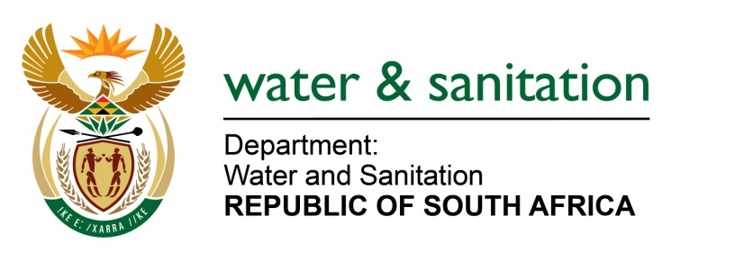

NATIONAL ASSEMBLY

FOR WRITTEN REPLY

QUESTION NO 2254

DATE OF PUBLICATION IN INTERNAL QUESTION PAPER: 02 JUNE 2023
(INTERNAL QUESTION PAPER NO. 21)
2254. Mr V Pambo (EFF) to ask the Minister of Water and Sanitation:
Whether there are any reasons that the Government has abandoned the 784 000 litre water storage donated to the residents of kaMahoyi in Ward 11 in the Nkomazi Local Municipality; if not, what is the position in this regard; if so, what are the relevant details? NW2560E
---00O00---
MINISTER OF WATER AND SANITATION
The Department of Water and Sanitation (DWS) and Nkomazi Local Municipality (LM) conducted a site inspection at 2ML reservoir in Ka-Hhoyi area. It was established that the concrete reservoir was leaking at the bottom. The Municipality indicated that a contractor will soon be appointed to inspect and repair the leaking reservoirs and several other water storages within the jurisdiction of Nkomazi LM.

The Municipality reported that a visual structural assessment was conducted to water storages within the jurisdiction and the report is in possession of the Municipality. Currently the Municipality advertised tender for the refurbishment of the water storages, which closed on the 24th of April 2023. The procurement process for appointment is planned to be concluded before end of September 2023. The project is funded by Nkomazi Local Municipality and the ward 11 water storage is one of the infrastructures that will benefit from the programme.

---00O00---

