5262222222,../.
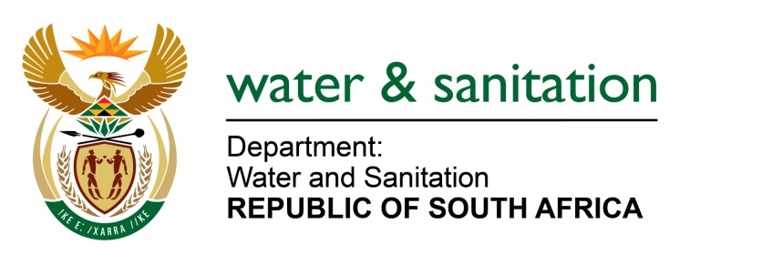

NATIONAL ASSEMBLY

FOR WRITTEN REPLY

QUESTION NO 2254

DATE OF PUBLICATION IN INTERNAL QUESTION PAPER: 10 SEPTEMBER 2021
(INTERNAL QUESTION PAPER NO. 22)

2254. Mr K Ceza (EFF) to ask the Minister of Water and Sanitation:

What is his department’s current (a) national backlog for the installation of boreholes in rural municipalities and (b) time frame for completing the (i) installation of boreholes and (ii) building of dams in this regard? NW2561E

---00O00---
MINISTER OF WATER AND SANITATION

- The installation of boreholes falls under the mandate of municipalities in line with Section 84(1)(d) of the Municipal Structures Act which mandates that municipalities are responsible for the provision of potable water within their areas of jurisdiction.

(b) (ii) As per the Department of Water and Sanitation Annual Performance Plan and funding for the 2021/22 financial year, progress for the following construction of the following dams is as follows:

No | Project | Progress | Estimated date of completion
1 | Raising of Hazelmere Dam | 96% construction | August 2022
2 | Raising of Clanwilliam Dam | 12% construction | April 2026
3 | Raising of Tzaneen Dam | 10% construction | June 2023
4 | Mzimvubu Water Project | 20% construction (Advanced Works-Access Roads) | Completion to be confirmed on finalisation of construction drawings
5 | New Nwamitwa Dam | - Procurement completed  - Designs completed | Completion to confirmed on sequencing of the work packages and availability of long term funding
6 | Lusikisiki Regional Water Supply Scheme: Zalu Dam | - 43% design completion with estimated  - 100% design completion | Date of completion to be confirmed on finalisation of specialist services appointment
6 | Algoa Water Supply System: Corney Dam | 0% Design stage | October 2022 for completion of designs
7 | Umkhomazi Water Project | Project preparation stage | 2027

---00O00---

