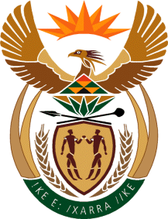

MINISTRY: COMMUNICATIONS
REPUBLIC OF SOUTH AFRICA
Private Bag X 745, Pretoria, 0001, Tel: +27 12 473 0164 Fax: +27 12 473 0585
Tshedimosetso House,1035 Francis Baard Street, Tshedimosetso House, Pretoria, 1000

NATIONAL ASSEMBLY
QUESTION FOR WRITTEN REPLY
QUESTION NUMBER: 2253
DATE OF PUBLICATION: 28 OCTOBER 2016

Mr C H H Hunsinger (DA) to ask the Minister of Communications:
- a) How many government-sponsored set-top boxes have been installed since her reply to question 685 on 24 May 2016 to date, and (b) what is the detailed breakdown of the (i) municipal areas and (ii) provinces where the specified set-top boxes were installed;

- Whether all of the specified set-top boxes that were installed are Direct to the Home set-top boxes; if not, what is the total number of the specified set-top boxes that are Digital Terrestrial Television set-top boxes; if so, what are the relevant details? NW2583E

REPLY: MINISTER OF COMMUNICATIONS
(1)
(a) A total of 22,387 STBs have been issued, installed and service activated as at 31 October 2016
(b) (i) (ii) Attached is a spreadsheet showing the municipal areas and provinces.
(2) A total of Direct To Home (DTH) STBs installed as at 31 October 2016 is 14,143 and Digital Terrestrial Television (DTT) are 8,244. Refer to attached spreadsheet for details.

MR NN MUNZHELELE
DIRECTOR GENERAL [ACTING]
DEPARTMENT OF COMMUNICATIONS
DATE:

MS AF MUTHAMBI (MP)
MINISTER OF COMMUNICATIONS
DATE

