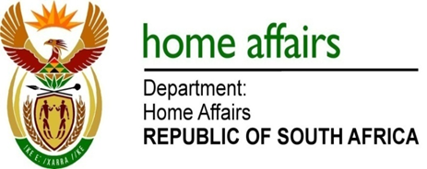

NATIONAL ASSEMBLY

QUESTION FOR WRITTEN REPLY

QUESTION NO. 2252

DATE OF PUBLICATION: FRIDAY, 17 AUGUST 2018

INTERNAL QUESTION PAPER 23 OF 2018

2252. Mr J Vos (DA) to ask the Minister of Home Affairs:

With regard to his announcement to include the names of both parents in the passports of minors, (a) what is the name of the company that was awarded the contract and (b) what amount is projected to be paid by taxpayers in this regard? NW2426E

REPLY:

- No contract was awarded specifically for this enhancement. The current DHA system was enhanced via the DHA modernisation/ Who Am I Online (WAIO) scope and printing is still done by Government Printing Works (GPW).

- The price of passport has not changed.

