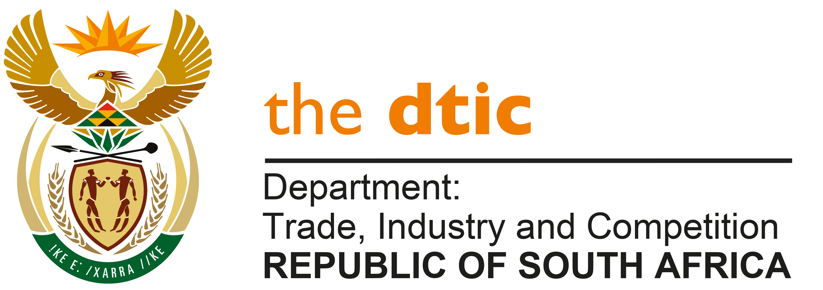

THE NATIONAL ASSEMBLY

QUESTION FOR WRITTEN REPLY

QUESTION NO. 2251

Mr F J Mulder (FF Plus) to ask the Minister of Trade, Industry and Competition:

- (a) Which development projects, such as Yekani Manufacturing (Pty) Ltd in East London, were established with the financial support of the Industrial Development Corporation during the past 10 financial years, (b) what were the amounts that were invested in each project, (c) which of the specified endeavours have since failed and (d) what are the reasons for their failure in each case;
- Whether he will make a statement on the matter? [NW2666E]

REPLY:

The IDC provides funding for companies based on the mandate to industrialise the economy and support broadening the base of the economy. A number of IDC investments are successful whilst some projects fail, for a range of reasons. These reasons may include changes in market conditions resulting in changes in either demand or costs, failure by investors to adhere to their commitments and counter-party challenges.
As a development finance institution, the IDC will normally take a higher risk profile than commercial banks.
The IDC publishes information in its annual reports on loans and equity approvals or disbursements that it makes and the level of impairment to its book, which includes amounts written off. In a number of cases, the IDC pursues recovery of funds where there is a legal basis for doing so, for example, that an investor has applied the funds for purposes different to what is in the funding agreement.
I have requested the IDC to review a number of its transactions in East London with a view to identifying common or unique reasons for investment projects failing or succeeding and will provide the Honourable Member with a supplementary reply on conclusion of the study, citing specific project details as appropriate.

-END-

