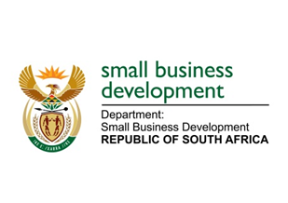
NATIONAL ASSEMBLY

QUESTION FOR WRITTEN REPLY

“2251. Mr H C C Krüger (DA) to ask the Minister of Small Business Development:

(1) Whether any Enterprise Incubation Programmes for small businesses and cooperatives have been piloted in the (a) Thembisile Hani and/or (b) J S Moroka Local Municipalities in Mpumalanga (i) in each of the past five financial years and/or (ii) since 1 April 2018; if not, in each case, why not; if so, what are the details of the (aa) sectors in which the incubators are piloted, (bb) number of clients that benefitted from incubators, (cc) number of jobs created and (dd) names and addresses of each incubator;
(2) whether any of the specified beneficiaries are supported by the (a) Small Enterprise Development Agency and/or (b) Small Enterprise Finance Agency; if so, what are the relevant details in each case?”
NW2425E

REPLY:

(1)(a)&(b) No.

(i) &(ii) The Enterprise Incubation Programme (EIP) has been operational since 1 April 2016. Since being operational, the Department of Small Business Development (DSBD) has not piloted the EIP for small businesses and cooperatives in the identified municipalities. The Department has received one application from the Thembisile Hani Local Municipality. However, the application was not successful as it did not meet the requirements.

(aa),(bb),(cc) & (dd) Not applicable.

(2) Not applicable.

