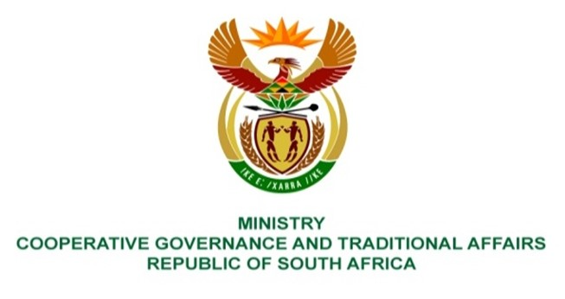

NATIONAL ASSEMBLY
QUESTION FOR WRITTEN REPLY

QUESTION NUMBER 225
DATE OF PUBLICATION: 10 FEBRUARY 2022

QUESTION:

225. Mr M M Chabangu (EFF) to ask the Minister of Cooperative Governance and Traditional Affairs:
- On what date is it envisaged the national state of disaster will come to an end; and
- what are the reasons for the unending extensions?
NW229
REPLY:

- The National State of Disaster is envisaged to end by the 5th April 2022.

- The national state of disaster was extended each time following the determination by the National Coronavirus Command Council and Cabinet that the need to augment the existing legislation and contingency arrangements through the disaster management regulations was still required.

