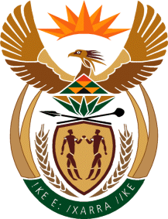

MINISTER IN THE PRESIDENCY: REPUBLIC OF SOUTH AFRICA
Private Bag X1000, Pretoria, 0001, Union Buildings, Government Avenue, PRETORIA
Tel: (012) 300 5200, Website: www.thepresidency.gov.za

NATIONAL ASSEMBLY

WRITTEN QUESTION FOR WRITTEN REPLY

QUESTION NUMBER: 225

DATE OF PUBLICATIONS: 11 February 2021

225. Mr M S Malatsi (DA) to ask the Minister in The Presidency:
What are the reasons that The Presidency has not fired a certain person (name and details furnished) for failure to submit financial disclosures and embarrassing The Presidency through the person’s involvement in the contract (details furnished), given the President’s stated mission to fight corruption? NW228E

REPLY:
In the course of the investigation into the affairs of the Gauteng Department of Health concerning irregularities in the appointment of a service provider to supply Personal Protective Equipment (PPE), the Special Investigating Unit (SIU) informed The Presidency that a senior Presidency official may have committed misconduct in violation of the Public Service Act, 1994.

The SIU consequently recommended the instituting of disciplinary proceedings against the official. In terms of possible misconduct identified by the SIU, the official has been placed on precautionary suspension in accordance with paragraph 2.7 (2), Chapter 7 of the SMS Handbook, pending an internal investigation into the official’s alleged misconduct. The outcome of the internal investigation will determine the cause of action to be taken by The Presidency in compliance with the law.

Thank You.

