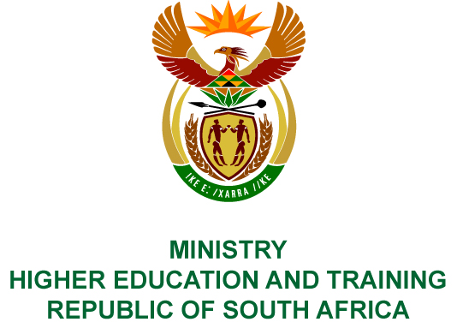
Private Bag X893, Pretoria, 0001, Tel (012) 312 5555, Fax (012) 323 5618
Private Bag X9192, Cape Town, 8000, Tel (021) 469 5150, Fax: (021) 465 7956
Memorandum from the Parliamentary Office
NATIONAL ASSEMBLY
FOR WRITTEN REPLY
QUESTION 225
DATE OF PUBLICATION OF INTERNAL QUESTION PAPER: 16/02/2018

(INTERNAL QUESTION PAPER NO 2 OF 2018)
Ms N Nolutshungu (EFF) to ask the Minister of Higher Education and Training:
Whether any of the board members of the National Institute for Humanities and Social Sciences were recipients of any grant awarded by the Humanities Hubs programme of the specified institute in the (a) 2014-15, (b) 2015-16 and (c) 2016-17 financial years; if so, (i) what is the name of each recipient, (ii) what amount was each recipient awarded in grant funding as at 13 November 2017, (iii) what amount is each recipient still to be awarded, (iv) what was each grant awarded for and (v) did each grant comply with the cost cutting measures and regulations of (aa) the National Treasury, (bb) her department and (cc) the Auditor-General of South Africa?
NW246E

REPLY:
The National Institute for Humanities and Social Sciences (NIHSS) has provided the following response to the questions posed.
None of the NIHSS board members were recipients of grants awarded by the Humanities Hubs programme in the three financial years in question.

