

**MINISTRY**

**STATE SECURITY**

**REPUBLIC OF SOUTH AFRICA**

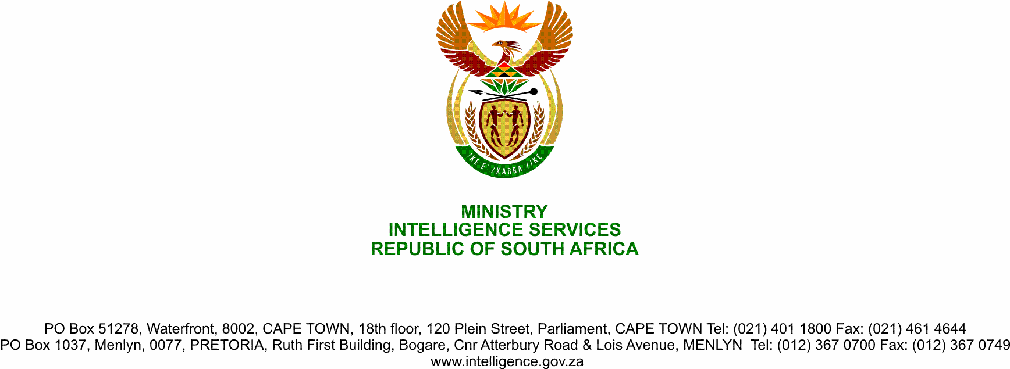

**NATIONAL ASSEMBLY**

**QUESTION FOR WRITTEN REPLY**

**QUESTION NO.:** **2248.**

**Ms D Kohler (DA) to ask the Minister of State Security:**

In light of the fact that there is no sign in the operations of the Joint Standing Committee on Intelligence that speaks to the recommendations of the High Level Panel report, what are the details of the progress that has been made in terms of the implementation of the recommendations of the High Level Panel report regarding the disproportionate application of secrecy?

NW2820E

**REPLY**

There is no disproportionate secrecy applied by the State Security Agency with regard to the Joint Standing Committee on Intelligence (JSCI) which oversees the State Security Agency. Section 4(1) of the Intelligence Services Oversight Act, 1994 (Act 40 of 1994) (“the Act”) makes it mandatory that the JSCI shall, in the performance of its functions, have access to intelligence, information and documents in the possession or under the control of a Service, notwithstanding anything to the contrary contained in any other law or the common law, but subject only to the stated conditions in the Act.

Progress reports on implementation of the High Level Review Panel Report were presented to the Parliament Joint Standing Committee on Inteligence (JSCI). The Honourable D Kohler, Member of Parliament can access these progress report from the JSCI.