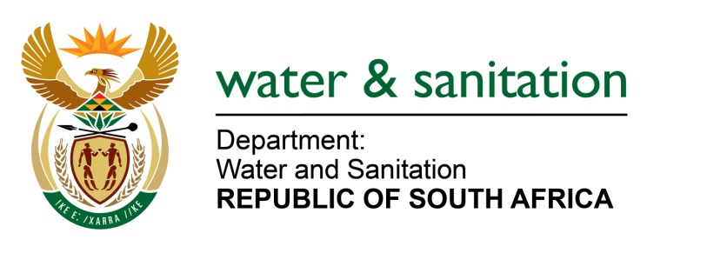

NATIONAL ASSEMBLY

FOR WRITTEN REPLY

QUESTION NO 2247

DATE OF PUBLICATION IN INTERNAL QUESTION PAPER: 02 JUNE 2023
(INTERNAL QUESTION PAPER NO. 21)

2247. Mrs M R Mohlala (EFF) to ask the Minister of Water and Sanitation:
What specific measures has he recently undertaken to address the mismanagement of the water supply, neglect of infrastructure, political influence and corruption in water management, in order to effectively tackle the water crisis and safeguard the constitutionally enshrined human right to water? NW2550E
---00O00---

MINISTER OF WATER AND SANITATION

The Department has identified issues that need to be addressed and measures to be implemented for water security and effective water services management:
- Introducing more specific minimum requirements to operate water and sanitation services, to include this in an operating license. This will mean strengthening enforcement through directives and amending Section 63 of the Water Services Act - to follow a more effective approach used in the National Water Act, clearly defining what functions the WSP is accountable for, what to report on and performing, which will mean regulation amendments in order for the department to effectively intervene where there is non-compliance.

- Broadening of South Africa’s water resource mix is critical for water security as there are now limited opportunities for further surface water developments. Additional sources to surface water like groundwater; desalination of sea water; return flows from treated waste-water systems; reuse of other poor-quality water such as acid mine drainage must be explored. Timeous implementation of large-scale investment in all the above types of water resource development projects is required to ensure water security.

- The Department is continuously identifying delivery hotspots at provincial level through Ministerial visits and deliberations/consultations with Local Municipalities. The Department has intervened through the implementation of over 70 projects that have been identified as Ministerial Priority Actions to address hotspot areas across the country. In some Provinces, both Political and Technical Steering Committees have been established to engage and monitor progress of these interventions, with involvement of The Department of Cooperative Governance and Traditional Affairs (CoGTA), Municipal Infrastructure Support Agent (MISA), South African Local Government Association (SALGA), and the Water Boards.

- The Department is currently implementing a national programme to develop Five-Year Water and Sanitation Services Reliability Implementation plans at Water Services Authority level. These plans will look at the demographics of all areas, water and sanitation needs assessments, infrastructure functionality status, infrastructure refurbishment requirements, water security and governance issues. In consultation with all municipalities, this process will result in a comprehensive situational assessment of all water and sanitation services at community level and through the implementation of reliability principles a pipeline of projects being developed that will integrate all grant funding to specifically address the provision of reliable water and sanitation services.
---00O00---

