

**MINISTRY**

**STATE SECURITY**

**REPUBLIC OF SOUTH AFRICA**

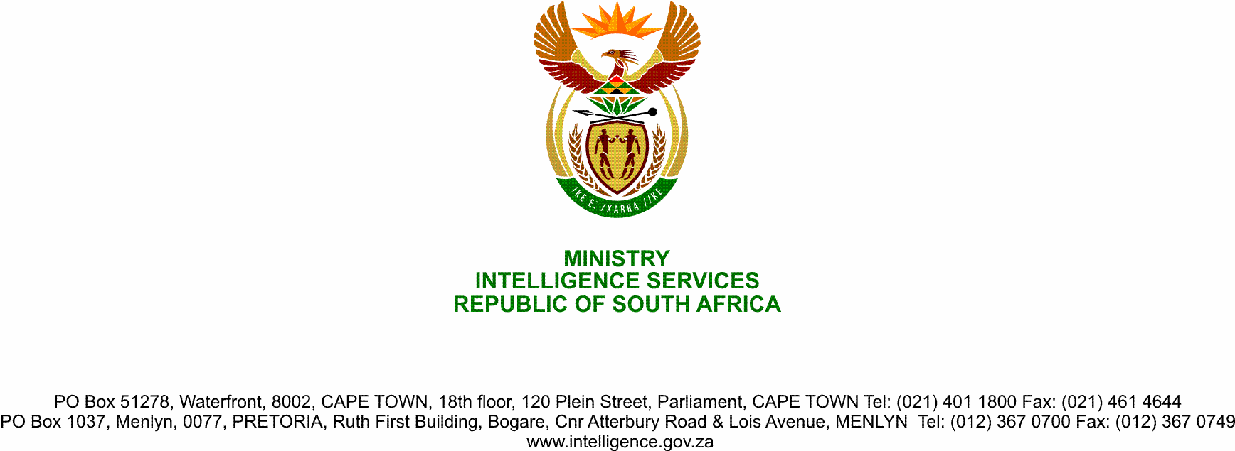

**NATIONAL ASSEMBLY**

**QUESTION FOR WRITTEN REPLY**

**QUESTION NO.:** **2247.**

**Ms D Kohler (DA) ask the Minister of State Security:**

(1) With reference to the recommendations of the High Level Panel report, (a) what has been done to deal with the politicisation and factionalisation within the State Security Agency (SSA) and (b) how has the issue of those with liberation struggle background who are unable to separate their professional responsibilities from their political inclinations been dealt with;

(2) how far along is the dismantling of the parallel structures created under the Zuma era, in breach of the Constitution of the Republic of South Africa, 1996, and legislation;

(3) how far along is the reversal of the amalgamation of National Intelligence Agency and SA Secret Service into the SSA;

(4) (a) who has been held to account for the moves referred to above and (b) on what date will action be taken against the responsible person(s)?

NW2819E

**REPLY**

Reply to this Parliamentary Question has been logged with the Parliament Joint Standing Committee on Intelligence (JSCI), which has also received briefing on the Progress with regard to the implementation of the recommendations in the High Level Review Panel Report.