FOR Y#fiOTgN REPLY
QUESTION 2244

NATIONAL ASSEMBLY
3e/1/a/1\20210o304)

DATE OF PUBI•tCATION IN INTERNAL QUE9TION PAPER: 1§ SEPTEgjBER 2021 (INTERNAL QUESTION PAPER NO 22-2021)

2244. Els A gl M Weber (DA) to ask the Minister of Pollco:

Whether he will furnish Ms A M M Weber with a list of all dockets, including the docket numbers. of all rhinos poached in all tho national parks specified according to the park; if not, why not; if so, what are the relevant details;

whether all dockets contain the forensic reports of the bullets retrieved from the rhinos; if not. why not; if°o, what are the relevant datails;
- whatker he wlll indlcate the number of casus that are ongoing in respect of each
  - park and (b) province; if not, why not; if sc, what are the relevant details:

what (a) number of rhino poaching casas (i) are stlll unresolved an0 (li) have been finalised nnd (b) was the outcome in each cese?

REPLY:
NW2fi40E

The information provided in this respohse, is for the 2020/2021 financial year.

Yes, a fiat of all Beckets, includlng the docket numbers, of all rhincs poached in all the national parks, specified according to the park, with relevant details, aro ae follows:

Nc cause
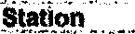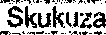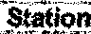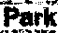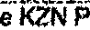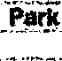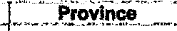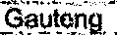
KwaZulu-Natul
1.
1.. .......-.. *
Mgumalariga
...,....
Mpurnala a

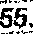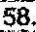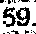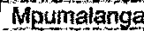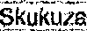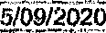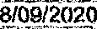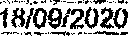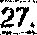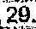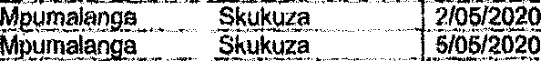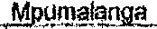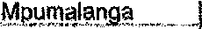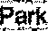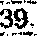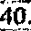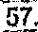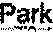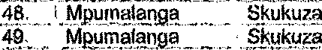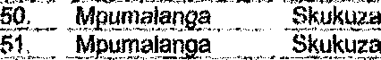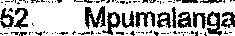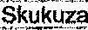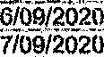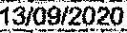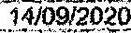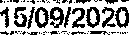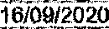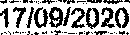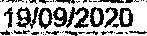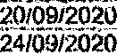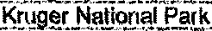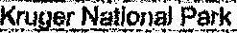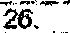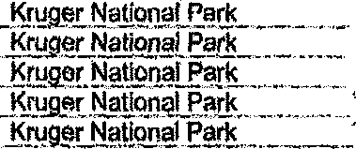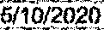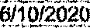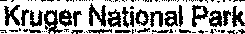9.

26. M_puin@laripa,

30.

Fark

37.

Perh
Kruger National
Kt«ger N,atlonal Park
Kiuger National ParL

Kruger National Patk Kruge,r Natiorial Pack

9/10/2020

!e5,.

4/11/2020

74,

7Y. “/8.

61.

Mp‹imolan a

_Mpumatanga _

Skukuza

1 /11/2020

20/11/2020

1/12/2n20

89.
90. [
81.,

' 94.

07,
e6.

Purk

Fark

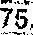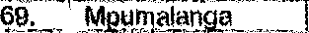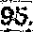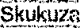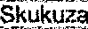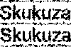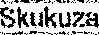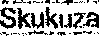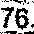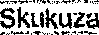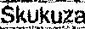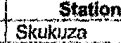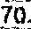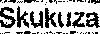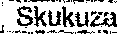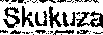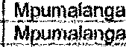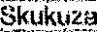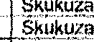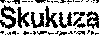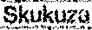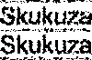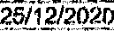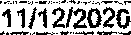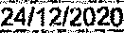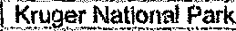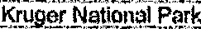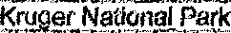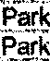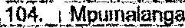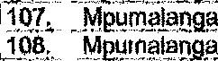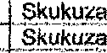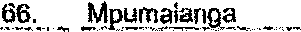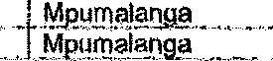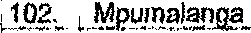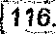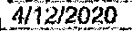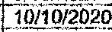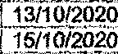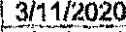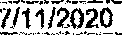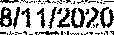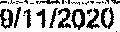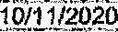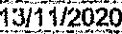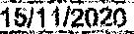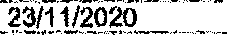
109.
11U,
111_ I1]2, 1 13.
114.

k2pumoJanpa MP!! alanga M unlalenga Mpumalni1g«

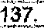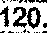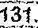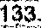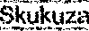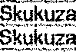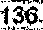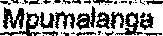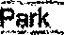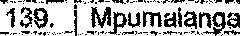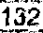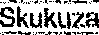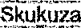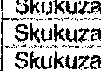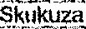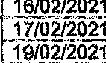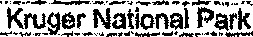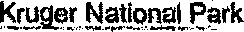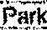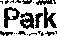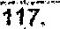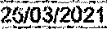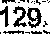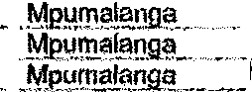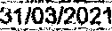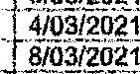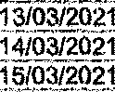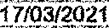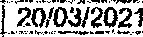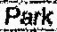
127'.
1/05/2021
4/05/2021
"130.
KnigarNational Fark
ltnipsr Nations! Perk
j 21/03/2021

24/0:3/2021
K/uger National_Park
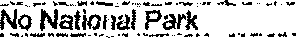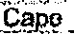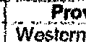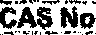
Province

casos I rhinu pgsching,

- No, not all the dockets contain forensic reports, as sama of the reports are still outstanding from thu Forensic Science Laboratory (FSL). Restrictions and rotation of personnel, in terms of COVID-19 protocols, to prevent the spread cf the Coronovlru3, inpactert negatively on thu immediate attention to thase reports. The roports, that have bnen received, are filed in the dockets.

Thu number ot cases, that are ozs •s in re9pect nf aach park and province, is reflected below:
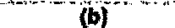

Kruger”Nalion al

The numbar of casas still undar investigation, finalised and tha outcome, is reflected below:
Numherof
(•›
143
11

Raplyto question 2244 recommended

ER:
GENERAL
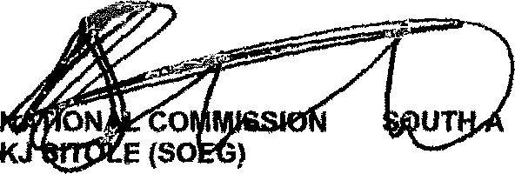
FRICAN POLICE SERVICE

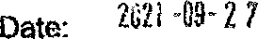

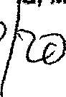Reply to. question 2244 epProved/n

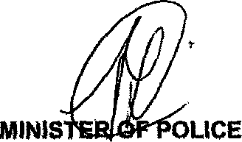
GENERAL BH CI E, MP

