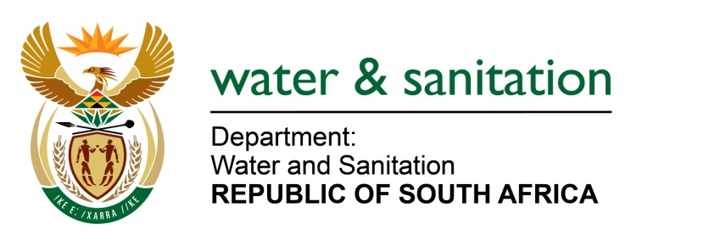

NATIONAL ASSEMBLY

FOR WRITTEN REPLY

QUESTION NO 2244

DATE OF PUBLICATION IN INTERNAL QUESTION PAPER: 12 JUNE 2015
(INTERNAL QUESTION PAPER NO. 21)

2244. Mrs Z B N Balindlela (DA) to ask the Minister of Water and Sanitation:
Whether (a) her department and (b) any entities reporting to her has paid out the remainder of any employee's contract before the contractually stipulated date of termination of the contract since the 2008-09 financial year up to the latest specified date for which information is available; if so, (i) what amount has (aa) her department and (bb) entities reporting to her spent on each such payout, (ii) to whom were these payouts made and (iii) what were the reasons for the early termination of the contracts in each specified case? NW2603E
---00O00---
REPLY:

(a) The Department of Water and Sanitation had two employees whose contracts were paid out before the contractually stipulated date of termination amounting to R2 274 513.50 for the 2008-09 financial year.

(a)(ii) Payouts were made to NJ Ngele amounting to R2 251 602.00 and OO Ayaya amounting to R22 911.59.

(a)(iii) The reasons for the early terminations were: NJ Ngele - The employer paid the employee 24 months of the employee's salary as per settlement agreement; OO Ayaya - The employer discharged the employee from the Public Service. An amount of R22 911.59 in terms of leave discounting was paid to the employee.
(b) None of the entities reporting to me has paid out remainder of any employee’s contract for the 2008-09 financial year.
---00O00---

