DATE OF PUBLICATION OF INTERNAL QUESTION PAPER: 03/06/2022
INTERNAL QUESTION PAPER: 22/2022

2243. Mr S L Ngcobo (IFP) to ask the Minister of Basic Education to ask the Minister of Basic Education:
Considering where we are currently globally and nationally with the COVID-19 pandemic, what (a) has her department recorded as the amount of school time that has been missed as a direct and/or indirect result of the pandemic as at the latest specified date for which information is available and (b)(i) measures have thus far been put in place to make up for lost time and (ii) are the details regarding the effectiveness of such measures?
Response
a) School closures and lost contact time
After schools closed on the 18th of March in 2020, in response to the initial spread of COVID-19 in South Africa, a phased approach to reopening schools was adopted by the government. This meant that the amount of time that schools were closed varied across grades. Moreover, once schools were reopened they had to adhere to social distancing rules, which had the inevitable effect that most schools adopted some form of rotational timetabling. The overall effect of school closures and rotational timetabling meant that in some grades up to 60% of the 2020 school year was lost, as the figure below shows.

Figure 1: School days in 2020 by grade
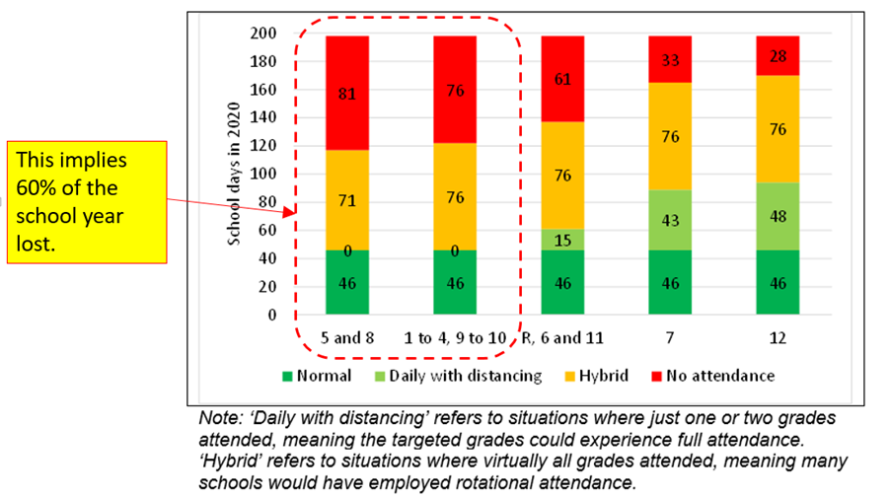

After schools were reopened, contact teaching time was still compromised throughout 2020 and 2021 due to rotational timetabling systems. A large survey of no-fee primary school schools in the North West Province in term 3 of 2021 revealed that in 60% of the 190 schools visited, the school was on a rotational schedule. These findings are roughly in line with patterns observed in no-fee schools in Limpopo Province (Ardington & Henry, Funda Wande Limpopo Evaluation, 2021). A Department of Basic Education analysis of 2021 Term 3 administrative data on attendance suggested that approximately 22% of contact time in Term 3 of 2021 was lost nationally, but that in schools where rotational timetabling was still being implemented the amount of lost contact time was as much as 50%.

Figure 2: School attendance in 2021 in the North West Province
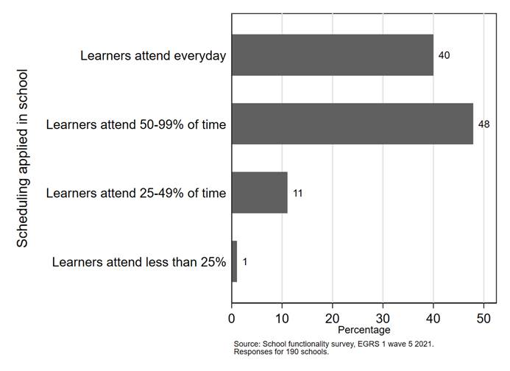
(b) (i) Measures in place to make up for lost time: The Three year Recovery Annual Teaching Plans (ATPs), which is a trimmed curriculum, provides guidance on core content, concepts and skills per subject and grade that teachers should prioritise. Mediation sessions have been conducted by PEDs on the implementation of the Recovery Annual Teaching Plans. A directive has been issued to schools to focus on formative assessment to ensure that more time is allocated to teaching. The Assessment for Learning (AfL) approach has been promoted at all levels in the system. Mid-year examinations were replaced by controlled tests. The weightings of school based assessment versus examinations has been reviewed so that a greater weighting is allocated to school based assessment conducted by the teacher in the classroom. Remote and Digital Learning programmes such as Radio and television lessons are broadcast for catch-up. The Education Assistants and Reading Champions were employed and placed in schools to alleviate some of the teachers’ administrative responsibilities, to ensure that teachers focus on the teaching and learning. The DBE has officially declared that 2022 to 2024 will be focussing on learning recovery, based on the Recovery ATP (trimmed ATP), even though normal schooling has resumed across all schools. This will allow schools more time to recover the learning losses. Teachers have been advised to first assess the learning deficits, for each of the sections of the work to be taught, so that learners can be taken from where they are, to where they need to get to.
(ii) Provinces do report on the implementation of measures put in place to counter-act learning losses and the DBE monitors the implementation of these measures on an ongoing basis. However, given the extent of the learning losses, it may be pre-mature to evaluate the effectiveness of the learning recovery at this early stage. Evaluation studies in this regard are part of the DBE plan and will be implemented in 2023 and 2024.
For other details on how much contact time was list, please see attachment.

