MINISTRY OF POLICE REPUBLIC OF SOUTH AFRICA
Pfiyate Bag X9O80, Cape Town 8000 Tel: 021— 467 7010/21 Fax' 021— 467 7033 Private Bag X463 PRETORIA, 0001, Tel: (012) 39W 2800
2819/20

“‘” !" J 393

NATIONAL ASSEMBLY

FOR WRITTEN REPLY:

QUESTION 2240

DATE OF PUBLICATION IN INTERNAL QUESTION PAPER:17/08/20 W g (INTERNAL QUESTION PAPER NO (23-2018)

2240. Ms. D Kohler (DA) to ask the Minister of Police:

- What is the total cost to date to his department of the (a) Ieg‹za fe e £3 for the
Constitutional Court case of McBride v Minister of

(CCT255/15) [2016] and (b) restructuring of the Investigative Directorate (IPID) instituted by the former Nathi Nhleko;
Indepe ident p••ice
Minister <of lice, M, p

Whether, with regard to the costs incurred by his department as e •e uit e
former Minister's alleged unlawful actions, there are any plans 6 r the ,

Minister to face any consequences, including legal or
e
financier I ly Feparato

consequences; if not, why not; if so, what are the relevant details?
Reply:

- The total cost paid on legal fees, towards the Constitutional McBride v Minister of Police and Another (CCT255/15) Department: Civilian Secretariat for Police Service is R 9 041 232.•‹ ?•.

case
by the
0

- In the matter of McBride v Minister of Police, the Minister has bee n cited /n hip official capacity. Even though cost orders have been given a jainst bi: officials who have been deemed to have acted mala fide (bad faith), in this matter both the High Court and the Constitutional Court did root e* the

FOR WRITTEN REPLY: QUESTION 2240: DATE OF PUBLICATION IN INTERNAL QUESTION PAPER: 17 AUGUST 2018: (INTERNAL QUESTION PAPER NO 23-2018)

Minister to pay the costs of the proceedings de bonis propiis (out of his own pocket).

- So there are no plans for the former Minister to face any consequences, including legal or financially reparatory consequences

MR. PM JOANA
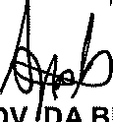
CHIEF FINANCIAL OFFICER (CSPS)
DATE: 0 6§ •
ADV. DA BELL " '

CHIEF DIRE TOR: LEGISLATION
DATE: ( @

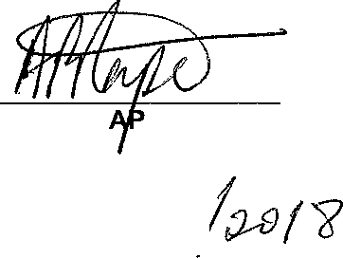
Reply to question 2240 recommended/men

MR. AP R EA
SECRETAi I POLICE SERVICE
DATE: /", @

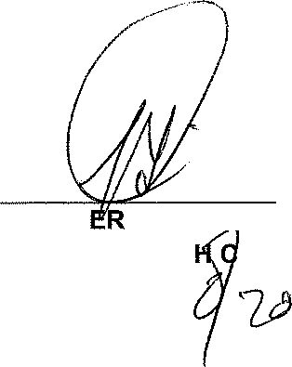
Reply to question 2240 approved/note

MINIST OF POLLCE HONORABL B ELE, MP DATE: g

2

