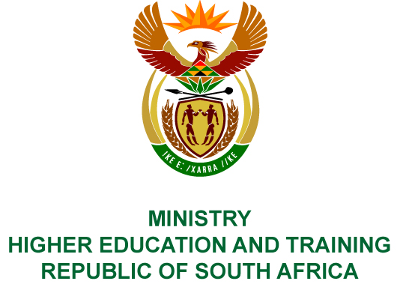
Private Bag X893, Pretoria, 0001, Tel (012) 312 5555, Fax (012) 323 5618
Private Bag X9192, Cape Town, 8000, Tel (021) 469 5150, Fax: (021) 465 7956
Memorandum from the Parliamentary Office
NATIONAL ASSEMBLY
FOR WRITTEN REPLY
QUESTION 224
DATE OF PUBLICATION OF INTERNAL QUESTION PAPER: 16/02/2018

(INTERNAL QUESTION PAPER NO 2 OF 2018)
Ms N Nolutshungu (EFF) to ask the Minister of Higher Education and Training:
What total amount has been spent by (a) her department and (b) the National Institute for Humanities and Social Sciences on Catalytic Research Projects in the (a) 2014-15, (b) 2015-16 and (c) 2016-17 financial years?
NW245E

REPLY:
The National Institute for Humanities and Social Sciences has provided the following responses to the questions posed.
- R1 125 600.
- R8 296 404.
- R9 971 580.

