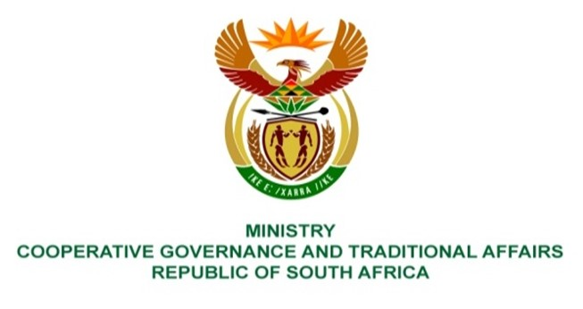

NATIONAL ASSEMBLY
QUESTIONS FOR WRITTEN REPLY

QUESTION NUMBER 2237
DATE OF PUBLICATION: 2 JUNE 2023
2237. Mrs T P Msane (EFF) to ask the Minister of Cooperative Governance and Traditional Affairs:
What are the relevant details of her department’s (a) plans and (b) time frames thereof in response to the Cholera outbreak in Hammanskraal, which she said include a water resilience plan, which would form the foundation of a bulk water supply and wastewater treatment plant infrastructure, rehabilitation and energy efficiency interventions within the water regulation and sewerage system? NW2536E
REPLY:
The Department of Cooperative Governance (DCOG) will continue to support Tshwane Metropolitan Municipality in accordance with section 154 of the Constitution. This will be done in accordance with the District Development Model (DDM) in collaboration with other sector departments including the Department of Water and Sanitation (DWS) as DWS is responsible for water regulation. DWS monitors the management of drinking water quality compliance by WSAs and further engages the WSAs where non-compliance is detected. WSAs are required to register for the monitoring programme on the DWS’s Integrated Regulatory Information System (IRIS). Following the release of the Blue Drop Watch Report by DWS on 6 June 2023, DCOG in collaboration with DWS is developing an action plan, to be submitted to Cabinet, that seeks to address the non-compliances in the treatment processes of drinking water and effluent.

Furthermore, DCOG has embarked on a process of identifying stalled water projects, among others, in mainly dysfunctional municipalities that are perennial under spenders of the Municipal Infrastructure Grant (MIG). DCOG has consulted with National Treasury and SALGA on the creation of MIG schedule 6B that will see DCOG implement the identified stalled projects in dysfunctional municipalities as a mitigating measure towards water resilience and universal access. The schedule 6B implementation will be done in this financial year.
End.

