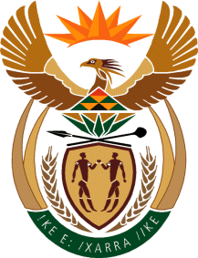

MINISTRY OF TOURISM
REPUBLIC OF SOUTH AFRICA

Private Bag X424, Pretoria, 0001, South Africa. Tel. (+27 12) 444 6780, Fax (+27 12) 444 7027
Private Bag X9154, Cape Town, 8000, South Africa. Tel. (+27 21) 469 5800, Fax: (+27 21) 465 3216

NATIONAL ASSEMBLY:

QUESTION FOR WRITTEN REPLY:
Question Number: 2236
Date of Publication: 2 June 2023
NCOP IQP Number: 21
Date of reply: 16 June 2023

Mr A Matumba (EFF) to ask the Minister of Tourism:
In light of how her department will be implementing 29 community-based tourism projects at the cost of R84 million for the 2023-24 financial year, which initiatives has she put in place to train the community to run their facilities, instead of having a management company playing the central role in training communities as is the case with Platfontein? NW2534E

REPLY:

I have been informed that the Department, in the past, did not do social facilitation for infrastructure projects.

I have, now, instructed the Department to use and implement the existing social facilitation process, as approved by Cabinet in 2021.

