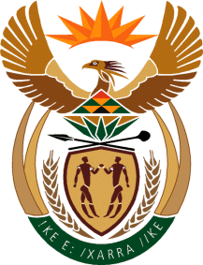

MINISTRY OF TOURISM
REPUBLIC OF SOUTH AFRICA

Private Bag X424, Pretoria, 0001, South Africa. Tel. (+27 12) 444 6780, Fax (+27 12) 444 7027
Private Bag X9154, Cape Town, 8000, South Africa. Tel. (+27 21) 469 5800, Fax: (+27 21) 465 3216

Ref: TM 2/1/1/10

NATIONAL ASSEMBLY:
QUESTION FOR WRITTEN REPLY:
Question Number: 2236
Date of Publication: 7 August 2017
NA IQP Number: 25
Date of reply: 22 August 2017

Mr J Vos (DA) to ask the Minister of Tourism

With reference to the recent fires in Knysna and her department’s commitment to provide assistance, what kind of assistance will her department provide to Knysna? NW2470E
Reply:
The Knysna municipality indicated that the impact assessment report will only be concluded by the 11th of August 2017. This report will provide the Department with accurate information on the number of unemployed people in the tourism sector who are affected by the Knysna fires. This information will enable the Department to conceptualise and implement the appropriate skills development interventions through the Working for Tourism Expanded Public Works Programme to absorb some employees who qualify from the affected establishments into short-term further training (with stipends) programmes in hospitality. The support to be provided by the Working for Tourism Programme will enable the Knysna hospitality businesses to retrain some of their workforce for a period whilst the hospitality establishments are in a process of rebuilding, it is important that this training effort supports the real demand for skills post rebuilding.

South African Tourism has activated all local and international platforms to highlight Knysna and the environs as a key tourism destination, ensuring the message is clear that the best support tourism can give Knysna is by visiting it and supporting the rebuild.
South African Tourism has worked with its key source markets internationally to bring out trade and social media for the past three months to showcase the region.

