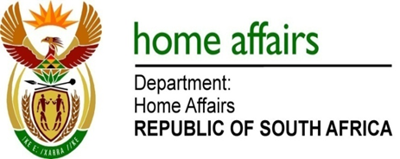

NATIONAL ASSEMBLY

QUESTION FOR WRITTEN REPLY

QUESTION NO. 2236

DATE OF PUBLICATION: Friday, 12 June 2015

INTERNAL QUESTION PAPER 21 OF 2015

2236. Mrs A M Dreyer (DA) to ask the Minister of Home Affairs:
Whether (a) his department and (b) any entities reporting to him has paid out the remainder of any employee's contract before the contractually stipulated date of termination of the contract since the 2008-09 financial year up to the latest specified date for which information is available; if so, (i) what amount has (aa) his department and (bb) entities reporting to him spent on each such payout, (ii) to whom were these payouts made and (iii) what were the reasons for the early termination of the contracts in each specified case?
NW2595E
REPLY:
Responses provided by the Department of Home Affairs, Government Printing Works and Electoral Commission are given below:

- Department of Home Affairs

The Department has not paid out the remainder of any employee's contract before the contractually stipulated date of termination of the contract since the 2008-09 financial year until 31 March 2015.

- According to the Government Printing Works

The Government Printing Works did not pay out the remainder of any employee’s contract before the contractually stipulated date of termination of the contract since the 2008-09 financial year up to date.

- According to the Electoral Commission

The Electoral Commission did not pay out the remainder of any employee’s contract before the contractually stipulated date of termination of the contract from the 2008-09 financial year up to date.

