36/1/4/1(201800220)
NATIONAL ASSEMBLY

FOR WRITTEN REPLY

QUESTION 2234

DATE OF PUBLICATION IN INTERNAL QUESTION PAPER: 17 AUGUST 2018 (INTERNAL QUESTION PAPER NO 23-2018)

2234. Mr D W Macpherson (DA) to ask the Minister of Police:

With reference to the KwaDukuza (Stanger) Police Station, what number of (a) arrests have been made with respect to stolen goods being sold at pawn shops in the jurisdiction of the Stanger Police Station since 1 April 2018 and (b) the reported cases of (i) murder, (ii) rape, (iii) house breaking, (iv) hijacking, (v) theft of motor vehicles and (vi) house robbery resulted in convictions in the 2017-18 financial year?
NW2408E
REPLY:

(a) One arrest has been made with respect to stolen goods which were sold at pawn shops in the jurisdiction of the KwaDukuza Police Station, since 1 April 2018.
(b)()(ii)(iii)(iv)(v)(v)

 | Crime | Reported | Cases to court | Convictions
(b)(i) | Murder | 74 | 42 | 2
(b)(ii) | Rape | 151 | 80 | 10
(b)(iii) | Housebreaking | 828 | 87 | 5
(b)(iv) | Hijacking | 27 | 5 | 0
(b)(v) | Theft of motor vehicle | 106 | 3 | 0
(b)(vi) | House robbery | 89 | 14 | 1

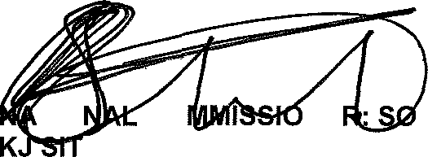
Reply to question 2234 recommended/

TIO CO OLE (SOEG)

GENERAL NE UTH AFRICAN POLICE SERVICE

2

Reply to question 2234 approved/not approved

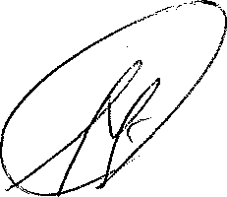
MINISTER OF POLICE BH CELE, MP

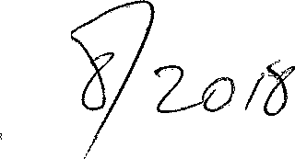
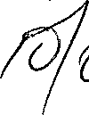
Date:

