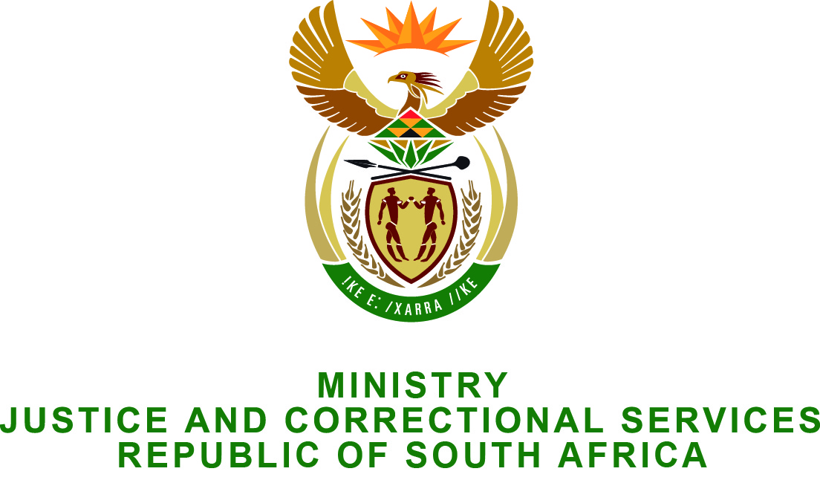

NATIONAL ASSEMBLY
QUESTION FOR WRITTEN REPLY
PARLIAMENTARY QUESTION NO.: 2233
DATE OF QUESTION: 12 JUNE 2015
DATE OF REPLY: 26 JUNE 2015

Mr SC Motau (DA) to ask the Minister of Justice and Correctional Services:
Whether (a) his department and (b) any entities reporting to him has paid out the remainder of any employee’s contract before the contractually stipulated date of termination of the contract since the 2008/2009 financial year up to the latest specified date for which information is available; if so, (i) what amount has (aa) his department and (bb) entities reporting to him spent on each such payout, (ii) to whom were these payouts made and (iii) what were the reasons for the early termination of the contracts in each specified case? NW2592E
REPLY:
The Minister wishes to inform the Honorable member that:
(a) The Department of Justice and Constitutional Development has no instance where the remainder of any employee’s contract was paid out before the contractually stipulated date of termination of the contract since the 2008-09 financial year to date.
(b) (i) Yes, out of the entities reporting to the Minister of Justice and Correctional Services, the National Prosecuting Authority has paid out employee contracts before the contractually stipulated date of termination of the contract. The details are as follows:
(bb) (i) Payout Amount | (ii) To Whom | (iii) Reason for early termination
R7,500,000 | Mr Vusi Pikoli, NDPP 2005 – 2009 | Payment made as a result of settlement agreements reached between the NDPP and the Presidency.
R17,357,233 | Mr Mxolisi Nxasana, NDPP 2013 – 2015 | Payment made as a result of settlement agreements reached between the NDPP and the Presidency.

(b) (ii)Legal Aid SA, the Office of the Chief Justice and the Special Investigating Unit have confirmed that there were no employees that were paid out their contract before the contractually stipulated date of termination of the contract.
The Department of Correctional Services or its entities does not have any employees whose contracts were terminated before the expiry of such contracts, and no paid outs made for the remainder of their contracts.
The Office of the Chief Justice was proclaimed as a National Department in 2010. From 2010 to 2015, the Office of the Chief Justice has not paid out the remainder of any employees’ contract before the contractually stipulated date of termination of their contracts.

