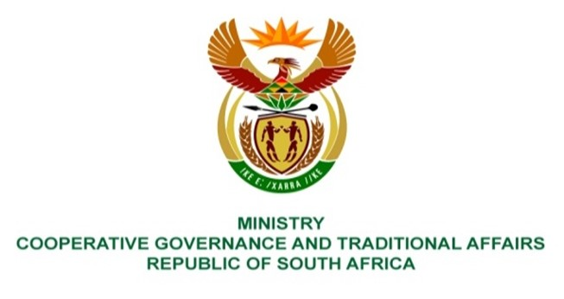

NATIONAL ASSEMBLY
QUESTION FOR WRITTEN REPLY

QUESTION NUMBER 2232.
DATE OF PUBLICATION: 02 JUNE 2023

2232. Mr K Ceza (EFF) to ask the Minister of Cooperative Governance and Traditional Affairs:
Whether she intends to demand (a) detailed reports from each municipality with regard to all municipal contracts and/or tenders and (b) Special Investigating Unit reports of the three financial years to improve accountability; if not, why not; if so, what are the relevant details? NW2530E

REPLY:

Municipalities are required to publish all tenders and contracts on their website and also on the municipal notice boards in accordance with section 75 of the Municipal Finance Management Act (MFMA). In addition, MFMA circular 83 advocates for publication of procurement information on tender portal, which requires municipalities to pulish all bids, awarded bids, cancelled bids, deviations, variations & extensions of existing contracts on the eTender Publication Portal. This is done as a way to promote a culture of transparancy and to give efffect to section 217 of the Constitution of the Republic of South Africa, 1996, which advocates for municipalities to procure goods and services in terms of a system which is transparent, fair, competitive, equitable and cost effective.
(b)
The Special Investigating Unit (SIU) referrals to municipalities are not done through the Minister, but through the MECs. If the MEC does not take the necessary action, then the SIU will escalate the matter to the Premier in the Province.
Furthermore, officials from the Department are collaborating with officials from the Presidency and the Department of Planning, Monitoring and Evaluation (DPME), who are assessing implementation of recommendations emanating from the SIU investigation reports. Should this broader assessment with the Presidency and the DPME identify matters that require my attention, I will ensure that the necessary steps are taken to ensure accountability.
The Department of Cooperative Governance (DCoG) in collaboration with the SIU established the Local Government Anti-Corruption Forum (LGACF) which is vital for purposes of fostering collaboration amongst the various stakeholders at local government in order to effectively fight corruption and co-ordinate efforts amongst provinces and law enforcement agencies. On a quarterly basis, the SIU provides progress on municipal investigations through the LGACF.
As such, the Department will continue to collaborate with the SIU and other law enforcement agencies to ensure that recommendations emanating from investigations reports are implemented and there is accountability.

End.

