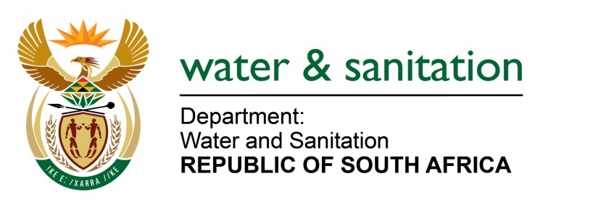

NATIONAL ASSEMBLY

FOR WRITTEN REPLY

QUESTION NO 2232

DATE OF PUBLICATION IN INTERNAL QUESTION PAPER: 10 JUNE 2022
(INTERNAL QUESTION PAPER NO. 23)

2232. Ms B Mathulelwa (EFF) to ask the Minister of Water and Sanitation: [Interdepartmental transfer from Cooperative Governance and Traditional Affairs with effect, Monday, 6 June 2022]
On what date is it envisaged that the residents of Umvoti Ward 13, who are drinking water with cattle from the river and relying on rain water, with no proper sanitation structures in place since 1994, will be provided with clean water services?
---00O00---
NW2648E

MINISTER OF WATER AND SANITATION
The Department of Water and Sanitation engaged the Mvoti Local Municipality regarding the provision of water and sanitation services to the residents of Umvoti in Ward 13. The municipality reported the following:
- A total of 1 603 households, 44% of them are served with water from the Mbuba stand-alone water scheme.
- Water is pumped from the production borehole to supply the 700 households.
- The water service backlog within Ward 13 stands at 56% (903 households) which are currently serviced with water tankers.
- The Mbuba water supply scheme currently runs on a diesel generator, and the municipality has plans to connect the plant to an ESKOM power connection due to huge operational costs.
- Regarding the sanitation services about 96% (1 543 households) are served with VIP sanitation system and there is a backlog of 60 households.
The municipality also indicated that it is currently not able to implement any new projects for water and sanitation services due to funding constraints and over commitment of grant funding for the MTEF period.

---00O00---

