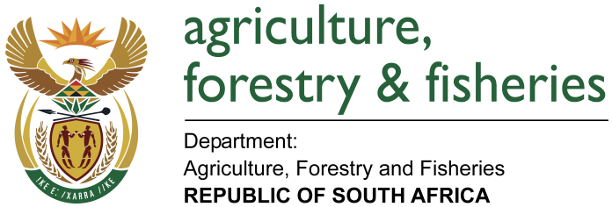
NATIONAL ASSEMBLY

WRITTEN REPLY

QUESTION 2231 / NW 2405E

MINISTER OF AGRICULTURE, FORESTRY AND FISHERIES:
Ms C King (DA) to ask the Minister of Agriculture, Forestry and Fisheries:

QUESTION:
What amount has his department spent on the (a) Magwa tea project and (b) Majola tea estate since 1 April 2011? NW2405E
REPLY:
a) Majola tea estate received funding to the tune of R 28 953 209, 00 since 2011 to date from equitable share.

b) Magwa tea estate received funding to the tune of R 115 625 289.56 since 2011 to date from equitable share.

- It should be noted that funding for the two enterprises was not sourced from the Department of Agriculture Forestry and Fisheries (DAFF) conditional grants;
- The response was provided by the Eastern Cape Department of Agriculture and Agrarian Reform (DRDAR);
- The DRDAR appointed their State Owned Entity the Eastern Cape Rural Development Agency (ECRDA) to manage the turnaround strategy of these tea plantations and;
- A report as submitted by ECRDA on activities and financial break down is attached.

