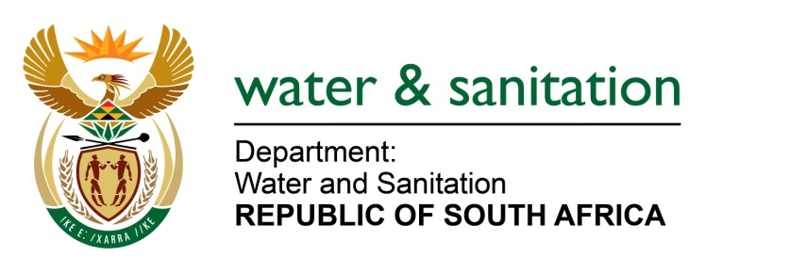

NATIONAL ASSEMBLY

FOR WRITTEN REPLY

QUESTION NO 2230

DATE OF PUBLICATION IN INTERNAL QUESTION PAPER: 02 JUNE 2023
(INTERNAL QUESTION PAPER NO. 21)

2230. Ms P Marais (EFF) to ask the Minister of Water and Sanitation:
What are the details of the steps of intervention that he has taken in Sterkspruit in Mangaung, where only one machine is working in the sewerage plant? NW2528E
---00O00---
MINISTER OF WATER AND SANITATION
The Department of Water and Sanitation (DWS) regularly conducts inspections and audits on the operation and maintenance of the Wastewater Treatment Works (WWTWs) in all Water Services Institution (WSIs) in the Free State, including Mangaung Metropolitan Municipality (MMM). The inspections aim to assess whether WWTWs are operated and maintained in a manner that does not pose risks of pollution resulting in contamination of water resources and increasing risks to human health and the environment.

The Sterkwater WWTW was operational even though there were some issues owing to poor maintenance of the plant. In July 2022 it was discovered that the WWTW is in a dilapidated state. DWS then conducted detailed investigations and found that theft of electrical cables has rendered the core process units of the WWTW non-operational. Following this initial investigation, a non-compliance letter dated 03 October 2022 was issued to the municipality. The Municipality did not respond to the non-compliance letter with an action plan to address the problems.

DWS conducted routine inspections at the WWTW again in January 2023, which found that the WWTW was still non-operational and the sewage from the inlet works was being diverted to the stormwater channel. DWS sent follow up correspondence in March 2023 regarding the poor conditions of the Sterkwater WWTW.

The DWS will proceed with administrative enforcement, thereby issuing a Notice for intention to issue a directive in June 2023, following the Mangaung Municipality’s failure to respond to the non-compliance letters issued. Although the municipality has not responded officially in writing to DWS letters, municipal officials indicated that Mangaung received a Special Grant from National Treasury to address the Sterkwater WWTW challenges, and the following measures are in place to restore its functionality:
- The municipality has stripped the electric motors and other electric and mechanical equipment that need repairs to determine the work to be done for restoration of the equipment.
- Electric cables have been ordered.
- The security company has been appointed to render armed response to protect the new cables to be installed.
- The plant should be running in the next three months.

---00O00---

