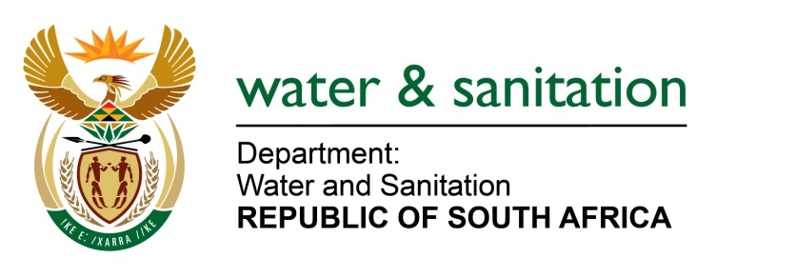

NATIONAL ASSEMBLY

FOR WRITTEN REPLY

QUESTION NO 2228

DATE OF PUBLICATION IN INTERNAL QUESTION PAPER: 21 OCTOBER 2016
(INTERNAL QUESTION PAPER NO. 31)

2228. Adv H C Schmidt (DA) to ask the Minister of Water and Sanitation:
(1) Whether, with reference to her reply to question 1716 on 27 September 2016, the funding allocated for the Sedibeng Regional Sewerage Scheme was spent in each financial year for which it was allocated; if not, in each case, why not; if so, in each case, what are the relevant details;
(2) whether any of the funds allocated for the specified scheme were underspent in each financial year for which the funding was allocated; if not, in each case, what is the position in this regard; if so, in each case, what are the relevant details? NW2558E
---00O00---

REPLY:

- The funding allocated for the Sedibeng Regional Sewerage Scheme was spent in each financial year as per allocation. The funding allocations and total expenditure from 2008/09 financial year to date are stipulated in Tables 1.1 and 1.2 below.

- There had not been any under spending in each financial year mentioned above and the budget allocation for each project was based on cash flow.

---00O00---

TABLE 1.1: Funding allocations for Sedibeng Regional Sewerage Scheme project
PROJECT NAME | 2008/09  R | 2009/10  R | 2010/11  R | 2011/12  R | 2012/13  R | 2013/14  R | 2014/15  R | 2015/16  R | 2016/17  R | TOTAL  R
Sedibeng Scheme | 3 780 818 | 20 153 503 | 18 800 000 | 31 542 099 | 5 939 776 | 31 969 522 | 93 679 032 | 141 217 387 | 274 057 560 | 621 139 697

TABLE 1.2: Expenditure to date for Sedibeng Regional Sewerage Scheme project
PROJECT NAME | 2008/09  R | 2009/10  R | 2010/11  R | 2011/12  R | 2012/13  R | 2013/14  R | 2014/15  R | 2015/16  R | 2016/17  R | TOTAL  R
Sedibeng Scheme | 3 780 818 | 20 153 503 | 18 800 000 | 31 542 099 | 5 939 776 | 31 969 522 | 93 679 032 | 141 217 387 | 166 370 793 | 513 452 930

