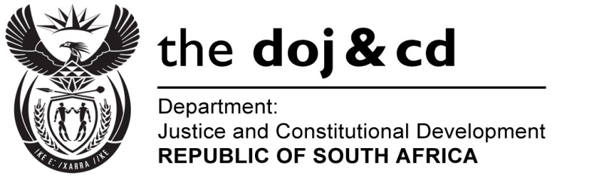
NATIONAL ASSEMBLY
QUESTION FOR WRITTEN REPLY
PARLIAMENTARY QUESTION NO: 2226
DATE OF QUESTION: 21 OCTOBER 2016

DATE OF SUBMISSION: 4 NOVEMBER 2016
Ms D Kohler (DA) to ask the Minister of Justice and Correctional Services:
(a) How many Special Investigating Unit investigations are currently being conducted into the Department of Public Works in each province, (b) what is the reason for each of the specified investigations and (c) by what date is each of the specified investigations expected to be finalised?
NW2556E

REPLY:

- The Special Investigating Unit (SIU) is currently conducting investigations authorised under four (4) proclamations involving the Department of Public Works (DPW). Details of the investigations are provided in the table below:
PROCLAMATION | PROVINCE | REASONS FOR THE INVESTIGATIONS | EXPECTED DATE TO BE FINALISED
- Proclamation No. R.54, 2014. There are seventeen (17) matters listed as well as an additional thirteen (13) matters listed in the amendment to the abovementioned Proclamation, amended to Proclamation No. R44 of 2015. | Western Cape | The Investigation relates to the refurbishment of ministerial homes in and around Cape Town at allegedly vastly inflated costs. The Proclamation concerned confines the investigation to:  - the procurement of goods and services; and  - unauthorized, irregular and/or fruitless and wasteful expenditure incurred in relation to the DPW projects listed in the two (2) Proclamations. | 31 March 2017
- Proclamation No. R59 of 2014 dated 27 August 2014 | National Department of Public Works | - Procurement and Administration of leases which is not fair, competitive, transparent, equitable or cost effective;  - Irregularities, malpractices or mal-administration in the affairs of DPW;  - Any related unauthorized, irregular or fruitless and wasteful expenditure;  - Theft, fraud and/or corruption by private individuals/landlords; and  - Procurement irregularities relating to service providers.  Currently, 649 leases are under investigation out of a total of 2 176 leases. The provincial breakdown is as follows:  - Eastern Cape – 142;  - Western Cape – 48;  - Mpumalanga – 105;  - Free State – 100;  - Kwa-Zulu Natal – 54;  - Gauteng – 136;  - North-West – 37; and  - Mthatha – 27. | March 2018
- Proclamation No. R38 of 2010 | Gauteng | - Allegations of irregular Supply Chain Management award in terms of Section 217 of the Constitution as well as fruitless and wasteful expenditure; and  - A lease investigation where we are in negotiations with the current landlord and DPW on overpayments to the landlord both in Gauteng. | Based on these matters (civil proceedings), SIU cannot anticipate the end date.
- Proclamation No. R27 of 2015 | Kwa-Zulu Natal | - Allegations of irregular appointment of service provider - 4 matters;  - Allegations of fruitless and wasteful expenditure - 1 matter;  - Allegations of fraud and corruption - 3 matters; and  - Allegations of conflict of interest - 420 matters. | September 2017
 | Western Cape | - Allegations of fraud and corruption - 2 matters; and  - Allegations of conflict of interest - 230 matters.
 | Eastern Cape | Allegations of conflict of interest - 344 matters
 | Pretoria Office | - Allegations of "cover quoting" - 7 matters;  - Allegations of irregularities in the Security Project - 1 matter;  - Allegations of irregular expenditures during the 2014/15 regularity audit - 1 matter;  - Allegations of fraud and corruption - 2 matters; and  - Allegations of conflict of interest – 2 705 matters.
 | Bloemfontein Office | - Allegations of poor service and non-delivery by service providers - 23 matters;  - Fraud and corruption - 1 matter;  - Allegations of conflict of interest - 677 matters; and  - Assisting the Hawks on 6 matters.

