

**MINISTRY**

**STATE SECURITY**

**REPUBLIC OF SOUTH AFRICA**

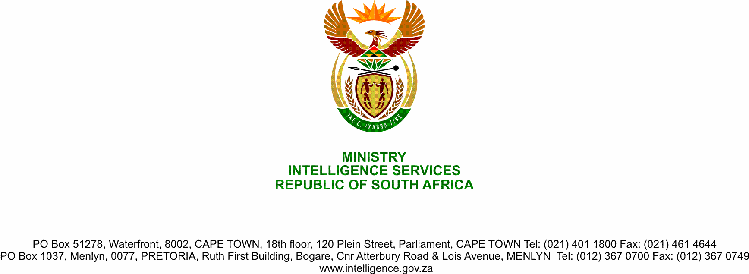

**NATIONAL ASSEMBLY**

**QUESTION FOR WRITTEN REPLY**

**QUESTION NO.:** **2225.**

**Dr M M Gondwe (DA) to ask the Minister of State Security:**

(1) Whether her department commissioned the recent lifestyle audits of the (a) Members of the Executive Councils of (i) the Eastern Cape, (ii) Gauteng and (iii) KwaZulu-Natal and (b) senior officials in each specified province; if so,

(2) Whether she will make the findings of the lifestyle audits available to the public; if not, why not; if so, what are the relevant details? NW2794E

**REPLY**

1. Yes, the State Security Agency was approached by the aforesaid provincial governments to conduct lifestyle audits of the members of the respective Executive Councils.
2. Reports of the lifestyle audits will be submitted to the respective provincial government, which will decide whether or not to make them available to the public.