

**MINISTRY**

**STATE SECURITY**

**REPUBLIC OF SOUTH AFRICA**

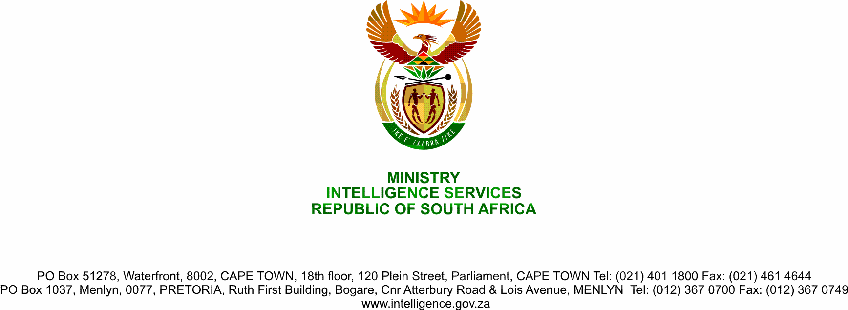

**NATIONAL ASSEMBLY**

**QUESTION FOR WRITTEN REPLY**

**QUESTION NO.:** **2224.**

**Dr M M Gondwe (DA) to ask the Minister of State Security:**

Whether the State Security Agency has the forensic capabilities to conduct lifestyle audits of the (a) Executive Councils of (i) the Eastern Cape, (ii) Gauteng and (iii) KwaZulu-Natal and (b) senior officials in each specified province; if not, why not; if so, what are the relevant details? NW2793E

**REPLY**

The State Security Agency possess partial forensic capabilities to conduct lifestyle audits and where there is a lack, collaborate with other organs of state such as the South African Police Services (SAPS), Financial Intelligence Centre (FIC), e.t.c. to compensate the discrepancy.

The lifestyle audit framework currently at the drafting stages will, once completed, lay a foundation of the requisite capabilities to conduct a lifestyle audit.