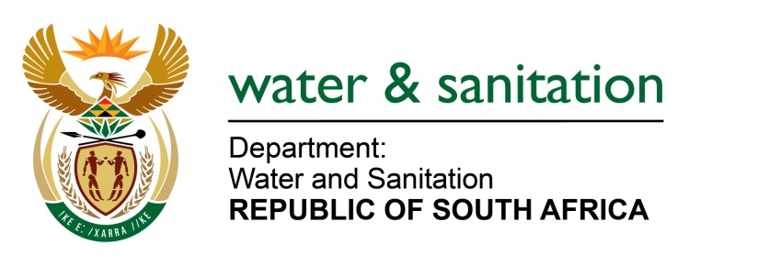

NATIONAL ASSEMBLY

FOR WRITTEN REPLY

QUESTION NO 222

DATE OF PUBLICATION IN INTERNAL QUESTION PAPER:
(INTERNAL QUESTION PAPER NO. 2) 17 FEBRUARY 2023

222. Ms T Breedt (FF Plus) to ask the Minister of Water and Sanitation:
(1) What are the reasons that work continued on the multi-million Rand sewage project in Deneysville, Free State, while the existing license has apparently expired in 2021;
(2) whether there is a new application to continue the project; if not, what is the position in this regard; if so, what are the relevant details.
(3) what are the reasons that public participation (a) was not done before embarking on the project, as is required with a project of this nature, (b) is only scheduled for the end of February, a month before planned completion and (c) is not to be held in the town affected, but in a neighbouring town;
(4) whether, considering that the project is set to be completed by end of March 2023, posts have been advertised for the plant; if not, why not; if so, (a) which posts have been advertised and (b) what are the (i) requirements and (ii) financial implications of the positions;
(5) whether the plant will open on time with relevant employed staff; if not, why not; if so; what are the relevant details?
NW226E
---00O00---

MINISTER OF WATER AND SANITATION

(1) The construction of the Refengkgotso (Deneysville) Wastewater Treatment Works (WWTW) commenced in 2017/2018 with the Contractor appointed on 9 May 2017, after the Water Use License (WUL), (14/C83M/CFGI/4681) was issued on 7 June 2016. The effluent discharge pipeline was constructed in 2017 and halted in 2017 when it was at 95% towards completion. At the time, the outstanding scope of work included the construction of the discharge end and the connection to the WWTW.
The WUL which expired and for which a new application is in process, is for the discharging of treated effluent into a water course, not for the construction of the WWTW. Currently, no effluent from the Refengkgotso (Deneysville) WWTW is being discharged into either the Vaal Dam or the Vaal River. Furthermore, no treated effluent will be discharged from the Refengkgotso WWTW before a WUL is in place.
(2) An application for the WUL which expired on 7 June 2021, was submitted, and is expected to be finalised by 31 May 2023. It should be noted that a Public Participation Process is not required for an application for a previously authorized WUL. However, a public participation meeting is scheduled to be held at the Deneysville Municipal Offices on 23 February 2023 at 17h00.
(3)(a) A Public Participation Process was convened before the project construction commenced at the Deneysville Primary School in Tank Street on 08 October 2015.
(b) The public participation meeting which was scheduled for 28 November 2022 could not take place due to the Engineer on the project passing on. Furthermore, the contractual arrangements between the Consultant and Metsimaholo had to be resolved first before the project activities could resume.
(c) The meeting was originally planned to be held in Refengkgotso, the residential area where the Deneysville WWTW is located. Refengkgotso is not a neighbouring town, it is a residential area of Deneysville. As indicated above, the meeting has been moved to the municipal offices of Metsimaholo in Deneysville.
(4)(a-b) The Deneysville WWTW will be owned and operated by the Metsimaholo LM once the construction and commissioning of the infrastructure has been concluded. Therefore, the municipality will be responsible for the advertising of posts and the appointment of the required personnel to operate the plant. The municipality has reported that it is already in the process of advertising the relevant posts. The DWS is not aware of further relevant details relating to the nature of posts to be advertised, the requirements and financial implications thereof. It is however estimated that the Deneysville WWTW will be classified as a Class C plant which will require the following operational staff according to Government Gazette No. 36958 of 23 October 2013 (Schedule 2 for Class of Works Rating, Schedule IV for Supervisor and Process Controller):
- 1 x Supervisor - Class V
- 4 x Process Controllers - Class III

(5) The Department has included an operational contract in the project in terms of which the Consultant will be assisting the Metsimaholo LM with the operation of the plant for 12 months after completion of the project.

---00O00---

