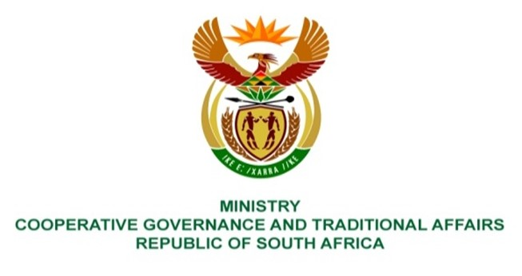

NATIONAL ASSEMBLY
QUESTION FOR WRITTEN REPLY

QUESTION NUMBER 2219
DATE OF PUBLICATION: 01 JUNE 2023
2219. Mr J F Smalle (DA) to ask the Minister of Cooperative Governance and Traditional Affairs:

(1) With regard to municipal service partnerships between provincial and local governments in respect of vehicle licensing paid between each province and local authority in the 2021-22 financial year, what was the (a) percentage split between each province and local municipality and (b) exact transactions recorded by each municipality;

(2) whether the provincial share was paid over to the province in the 2021-22 financial year; if not, (a) why not and (b) what are the outstanding license fee in each case to the province; if so what are the relevant details? NW2516E
REPLY:
The Department of Cooperative Governance and Traditional Affairs does not keep the records of vehicle licensing and fees. It is recommended that the honourable member redirect the question to Ministry of Transport who may obtain the required information from Provincial departments of Transports.
End.

