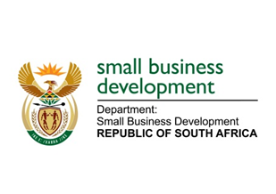
NATIONAL ASSEMBLY
QUESTION FOR WRITTEN REPLY
DUE IN PARLIAMENT: 17 JUNE 2022

2219. Mr D F Mthenjane (EFF) to ask the Minister of Small Business Development:
What has she found to be the impact on small businesses of the noncompliance with laws and regulations and the lack of adequate controls to collect all revenue from long-outstanding debtors, as was pointed out in the report of the Auditor-General for 2020 21 financial year? NW2628E

REPLY: I have been advised by the department as follows:

A joint study by the Departments of Small Business Development (DSBD) and Planning, Monitoring and Evaluation (DPME) on research on the delays and non-payment by government on small, medium and micro enterprises (SMMEs) concluded in June 2020 found that 56% of SMMEs, the majority of which were micro enterprises, were impacted by the delayed and non-payment by government. The recommendation was that the impact of this noncompliance with the 30-day payment policy was too large, especially given the compounding impact it has on not only business owners and their families but also employees and their families, and the recommendation was that government should take effective measures to enforce the 30-day payment policy. Legislative provisions for compliance to the 30-day payment policy falls within the ambit of jurisdiction of National Treasury. The DSBD’s role is to provide advocacy and awareness of these requirements and regulations. National Treasury has agreed and is currently in the process to strengthen these provisions.

Given the devastating effect that none and late payment of small enterprise supplier invoices has on the economic viability of the small enterprises, letters were written to our counterparts in provinces encouraging them to honour their payment obligations, especially to small enterprises, and to pay small enterprise suppliers within the agreed timeframes. As part of the DSBD current Roadshows and Partnership Dialogues that are being undertaken in all (nine) 9 provinces, counterparts at provincial and municipal level to ensure compliance to payment requirements to small enterprises whilst the regulations are being strengthened.

STELLA NDABENI-ABRAHAMS
MINISTER: SMALL BUSINESS DEVELOPMENT

