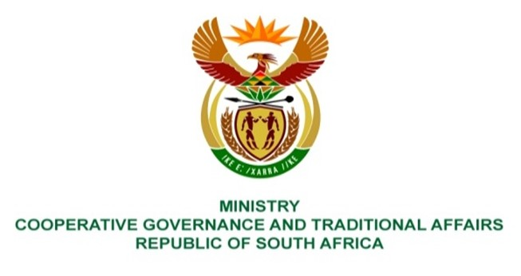

NATIONAL ASSEMBLY
QUESTION FOR WRITTEN REPLY

QUESTION NUMBER 2218
DATE OF PUBLICATION: 01 JUNE 2023
2218. Mr J F Smalle (DA) to ask the Minister of Cooperative Governance and Traditional Affairs:

(1) With reference to Circular 124 pertaining to municipal debt relief, (a) what ratio and/or criteria did she use to write off the debt owed by local municipalities to Eskom and (b) how does she intend to distribute the allocation;

(2) whether she envisages a similar bail-out for water service providers owed by local municipalities; if not, what is the position in this regard; if so, what format of the agreement will be followed;

(3) what is the current outstanding debt owed to (a) Eskom, (b) water boards and (c) water authorities by each (i) local and (ii) district municipalities;

(4) what are the details of creditors to whom municipalities currently owe payments for (a) 30 and (b) 60 days above? NW2515E
REPLY:
The information required by honourable member is administered by the National Treasury.
End.

