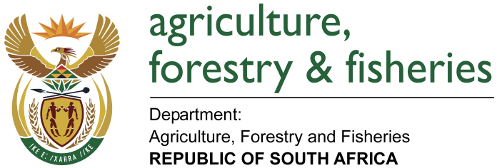
NATIONAL ASSEMBLY

WRITTEN REPLY

QUESTION 2218 / NW 2387E

MINISTER OF AGRICULTURE, FORESTRY AND FISHERIES:
Mr N Singh (IFP) to ask the Minister of Agriculture, Forestry and Fisheries:

QUESTION:

Whether he has engaged with the Minister of Trade and Industry and the Minister of Health on the viability of decriminalising and commercialising the growth and cultivation of hemp farming in South Africa; if not, on what date will engagement with the specified Ministers take place; if so, what are the relevant details? NW2387E

REPLY:

In terms of the current legislation, the mandate for regulating hemp lies with the Department of Health in terms of the Medicines and Related Substances Act of 1965 as well as the Department of Justice and Constitutional Development in terms of the Drugs and Drugs Trafficking Act of 1992. Thus, the Department of Agriculture, Forestry & Fisheries’ has mainly engaged these two departments.

The Department of Agriculture, Forestry and Fisheries (DAFF) is leading the inter-departmental team that is developing a new regulatory framework for hemp. The team is made up of the following departments: DAFF, Health, Trade and Industry, Environmental Affairs, Justice and Constitutional Development as well as the South African Police Services. The team also include state owned entities (SOEs) like Agricultural Research Council (ARC) and the Council for Scientific and Industrial Research (CSIR). The engagements between DAFF and other departments as well as SOEs take place through this platform. Much progress had been made in terms of dealing with technical matters regarding production of hemp, research and technology development, commercial feasibility and other related matters.

DAFF and the Department of Health are developing guidelines for regulating the cultivation and manufacturing of hemp and hemp products. As a result of the ongoing engagements amongst the different departments, DAFF has already formally requested the departments of Health and Justice and Constitutional Development to consider the necessary legislative amendments to allow for the commercialisation of hemp in South Africa. DAFF awaits a response from these departments.

