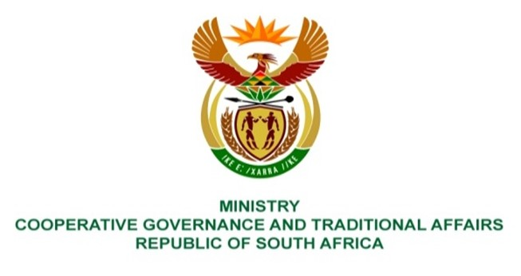

NATIONAL ASSEMBLY
QUESTION FOR WRITTEN REPLY

QUESTION NUMBER 2217
DATE OF PUBLICATION: 02 JUNE 2023
2217. Mr J F Smalle (DA) to ask the Minister of Cooperative Governance and Traditional Affairs:
With reference to the 2022 Greendrop Report making reference that 70,1% of our waste water treatment plants seemed to be in a critical state, what (a) plans have been put in place to refurbish and maintain the 840 sewerage plants, (b) are the current financial costs to upgrade all critical waste water treatment plants to meet the current specification and (c) additional plans and/or resources has each province set aside to comply with the provisions of the of the National Water Act, Act 36 of 1998? NW2514E

REPLY:
The recommendations and implementation of 2022 Greendrop Report are led and championed by Department of Water and Sanitation.
End.

