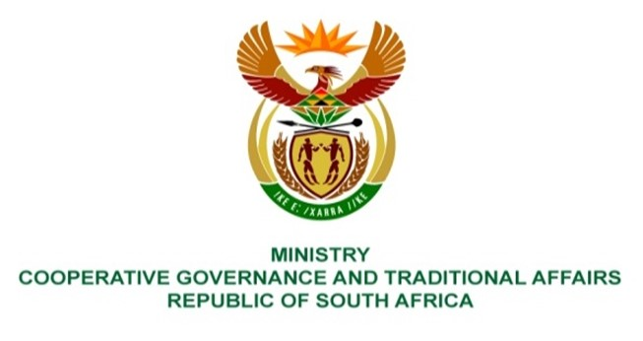

NATIONAL ASSEMBLY
QUESTION FOR WRITTEN REPLY

QUESTION NUMBER 2216
DATE OF PUBLICATION: 03 JUNE 2022

QUESTION:

2216. Mr K CEZA (EFF) to ask the Minister of Cooperative Governance and Traditional Affairs:

In light of the fact that the National Treasury divides conditional grants to municipalities in each financial year in terms of the equitable shares, what (a) are the impediments that prevent the provision of water, roads, toilets and streetlights in the (i) Dr J S Moroka Local Municipality, (ii) Amathole District Municipality, (iii) Phokwane Local Municipality and (iv) Bela-Bela Local Municipality, (b) oversight and monitoring mechanisms have been undertaken in the specified rural areas, (c) are the time frames for sending engineers to the areas and (d) are the reasons that it has taken long to deliver on the services? NW2624E

REPLY:
The department is currently obtaining the responses from the abovementioned munucipalities and we will provide response as soon as we receive it.

