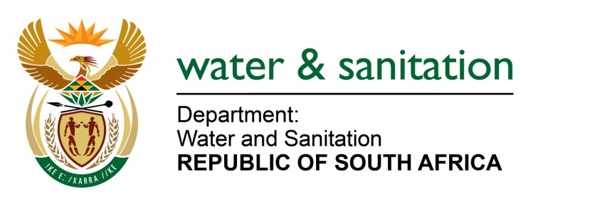

NATIONAL ASSEMBLY

FOR WRITTEN REPLY

QUESTION NO 2216

DATE OF PUBLICATION IN INTERNAL QUESTION PAPER: 07 AUGUST 2017
(INTERNAL QUESTION PAPER NO. 25)
2216. Mr T R Majola (DA) to ask the Minister of Water and Sanitation:
Whether, with reference to her replies to question 208 on 24 February 2017 and question 866 on 19 April 2017, the assessment that was conducted jointly by Ekurhuleni Metropolitan Municipality and Rand Water was completed in May 2017; if not, (a) why not and (b) on what date will it be completed; if so, will she make a full copy of the assessment available to Mr T R Majola? NW2448E
---00O00---
REPLY:
Request the Honourable Member to refer to the response to NA 1173 on 12 May 2017 which was adequately responded to and see Annexure A for details of the report on the assessment.
---00O00---

